928 Tech Talk: Replace timing belt and water pump (S4/GT/GTS) part II
(by Theo Jenniskens)
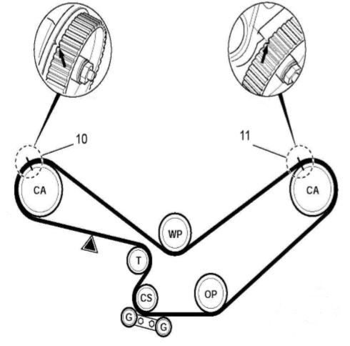
Part twelve in the series of tech talks, and this time we continue with major maintenance on the 928: replacing the distribution belt. It is a long publication and part 1 was already in a previous edition of the club magazine.
Let's recap: The 928's belt needs to be replaced periodically and this is a tough job. At the same time, major maintenance is required on all relevant parts at the front of the engine.
In part 1 we had stuck to the step-by-step plan and we had just removed the damper from the crankshaft.
- Now we disconnect the remaining cables and make sure they're out of the way. The spark plug cables don't really need to be removed, which makes mounting easier and less chance of errors later on (order).
- We can now remove the lower cover plate just above the crankshaft by loosening a few screws. Be careful when maneuvering: behind the cover plate there is a cable with a cable lug that connects the tensioner to the alarm wire. Undo it as soon as possible so that you don't pull it apart. With a little movement you can remove the lower cover plate. You can now see the whole course of the timing belt. Watch for any scraping. That's a signal that something's wrong. Check again if the belt wheels of the camshafts are on the mark where you put them.
- Now we're gonna loosen the tensioner. First loosen the locknut, then turn the tensioner bolt back. Some oil may run out, that's okay. Turn it far back so that the tension of the belt is released and it is loose.
- We're taking the belt off now. That is relatively easy now that it is loose. It is possible that one of the cam wheels suddenly turns due to the spring force of the valve springs. Don't be scared, look which way it turned. That's not abnormal that it turns a bit, but you have to turn it back later !!!!
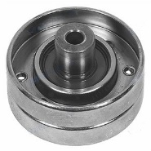
- Release the bracket above the tensioner arm, and carefully move the tensioner off the axle. It may be difficult to move (not good) and if necessary you can use a pulley puller. If you loosen the tensioner, it's good to know that the tensioner has a spring with a plunger in it. On the spring side of the plunger is a special washer. Don't lose it and look how it should fit. When the tensioner is off, the ring falls to the ground.
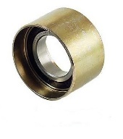
- Inspect the tensioner roller and the idle roller. The tensioner roller is crucial. If it has even a little play it will be replaced. Also check the two plastic bushes in the tensioner arm. They should be okay too. If you see any slack the tensioner arm will be skewed. The Idle roller is actually not that exciting. It makes sure that the belt straps can't touch each other and guides the belt when it is chattering a bit. The bearing wears out all the time and you can repair it right now. The idle roller bearing can be replaced with a new bearing if necessary. A bearing puller and a 6905ZZ bearing is necessary. The bearing is in a fitting rim and is easy to replace. (You can't replace the bearing of the idle roller.) Also check the rollers under the crankshaft and make sure they turn properly. They don't run normally and don't wear out but they can get stuck. Clean them now that you can reach them.
- The pump can now come off. If you didn't drain the coolant you have to place a collection container for about 5L. It will be a bit of a pool. Make a wad that fits in the place where the oil stick goes in the pan so no water runs into it. The pump still has 14 M6 bolts that need to be removed. Be careful not to break them. If they are very stuck (which shouldn't be) then it helps to give them a firm tap in the center. If you break them you have a challenge.
- When the pump bolts are loose the pump can still stick a bit. It has two pins that it fits on and also the gasket will let it stick a bit. Tap the housing with a screwdriver but don't pry between the pump housing and the motor, because you will damage the surface for the gasket.
- When the pump is off can you inspect the condition of the bearing. On the engine side you have to carefully remove the remains of the gasket with a razor blade, and finally you have to use fine sandpaper. Also check if everything is nice and clean.
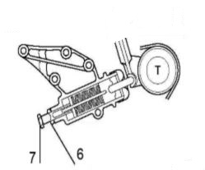
- You can remove the belt tensioner from the engine and clean and overhaul it if necessary. A new gasket is then needed, and it might be a good idea to replace the O-ring and rubber cover. Don't put any oil in it yet. Make sure you put the curved rings back in the tensioner in exactly the same way. The curved "Belleville" rings become flatter when the engine warms up and turns off (belt tension increases). The pressure in the tensioner decreases and so the series of rings thermally compensates the belt tension.
- Use an M6 tap end to clean the screw holes for the bolts. Be careful not to damage the thread.
- After we have cleaned everything we place the gasket for the pump against the motor. This will be mounted dry. No sealant in between or something like that. It helps if you put a little grease on it so that it stays in place better. The pump is now ready to go. Make sure the gasket doesn't get stuck somewhere in between so you will have a leak later on.
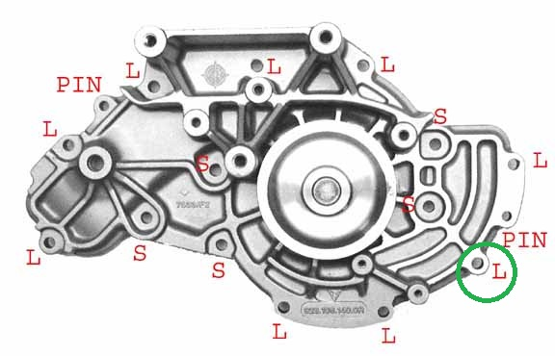
- The pump is fitted with 15 bolts. 9 long M6x25mm and 6 short M6x20mm. One is special see circle. It doesn't go directly into the pump but goes through the cover plate, so it has to be mounted later. We put some ceramic grease or Molycote TA on the bolts and carefully place them now, only then tighten with 9.5Nm. That's not very much, but enough. Use a torque wrench if possible because 9.5Nm is difficult to estimate.
- The old belt is still hanging somewhere because it cannot be removed without disconnecting the power cables. On the driver's side it is simple, just in front of the steering fluid reservoir there is a connection. Lift up the cover, unscrew the crosshead screw and lift the cable. It's handy to attach a rope before pulling it behind the frame in front of the reservoir. After all, it should be rerouted again in a moment.
- The second cable is trickier. On the passenger side there is a 14 pin plug that has to be removed, and under the 12v "fremdkontakt" connection and under the cap the thick power cable is fitted. You can take it off. Just behind the cam wheel is a cable bracket that holds the wiring harness in place, and also secures the ground connection for the ignition coil. It's very difficult to reach. The clamp has to be loosened because the cable has to come out. Then the whole cable behind the cam wheel has to go down and to the front. Again: attach a rope to it, because that makes rerouting easier. The space is very limited. If it really doesn't work there is another option. Pull the plug apart. Then it goes a lot easier. First make a drawing and picture.
- As soon as the two cables are disconnected the old belt can be removed and the new one can be put on immediately. The ropes make it easier to get the cables back in position and then fasten them. Clean the contact eyes of the power cables and put some "battery pole" grease on them.
- A nice challenge is the bolt at the tow eye on the pass.side of the engine. This is where the ground cable of the ignition coil is attached and the bracket that holds the thick cable in place. It is very difficult to attach the 10mm M6 bolt.
- Now you can put the belt tensioner back on together with the belt. Make sure you don't forget the ring of the plunger at the tensioner. First put on the belt on the pass side on the cam wheel. Make sure the cam wheel is on the marked spot. If necessary, turn back to the correct position. When the belt is in the correct trajectory, it can be placed on the driver's side last on the cam wheel. You check carefully whether the belt seems positioned correctly. Then we tighten the tensioner a bit. The belt pulls itself tighter and the cam wheels rotate a little. As soon as the belt starts to tighten a bit, the markings on the cam wheels should be perfectly positioned. If there is a tooth wrong, all has to be loosened and done again. Only when this is 100.0% correct you can continue.
- Next we fasten the bracket on top of the coolant pump and tensioner with two screws. The middle one is not yet, it will come later when the cover plate comes on.
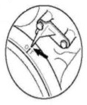
- Now it's time to start turning the motor by hand. We loosen the lock at the flywheel and put the 27mm bolt with pulley on the crankshaft. We turn the crankshaft clockwise and make sure that the belt follows its path. Listen to the pistons and make sure there is no blockage. Be sure to turn a few whole cycles.
- Set the camshafts to the TDC position, that's the position you marked at the beginning. To know what TDC is, you have to put the damper on the crankshaft so you know exactly that the red arrow on the coolant pump points to the O|T position. If all is well, the marks on the cam wheels should match nicely.
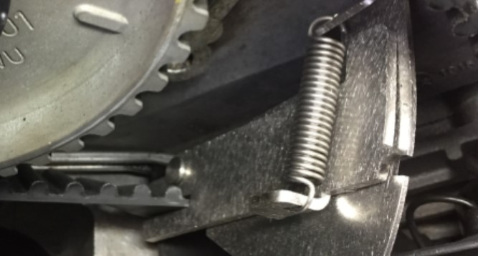
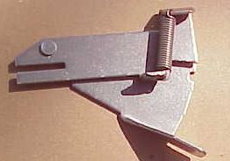
- We are now going to put the belt tension gauge on the low part of the belt to measure the tension. It is a very handy tool that measures the force needed to twist the belt in relation to the spring force. You put the tool on the belt that runs between tensioner and cam wheel, push it up against the back plate and see how far the spring is stretched. You turn the adjustment bolt of the tensioner forwards pieces so that the belt tension increases and the spring on the tool is stretched further during the measurement. As soon as the tension seems right you turn the engine once all the way around. The tension has to be distributed a bit more, so after one round you have to measure it again and if necessary you have to adjust it until the picture is like on the picture below. Now the two notches are opposite each other and the belt tension is good. Now tighten the locknut with a 17mm spanner so that the adjustment does not take place.
- This is the time to oil the tensioner. Loosen the two nipples with a 7mm spanner. With two hoses on the nipples, press oil into the upper nipple and collect oil from the lower nipple. Ordinary crankcase oil is ok. Purpose of the oil is some lubrication but especially heat conduction for the Bellevile rings so that the thermal compensation works.
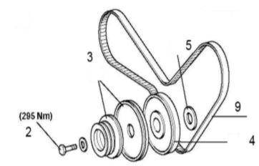
- We remove the damper on the crankshaft, mount the lower cover and put some grease on the crankshaft to put the damper and pulley back on. Re-assemble the flywheel clamp to prevent the crankshaft from rotating and tighten the 27mm bolt in the crankshaft. 250-295Nm of torque is quite strong.
- After this is done, the flywheel lock can be removed and the cover plate (or clutch cylinder) can be mounted again.
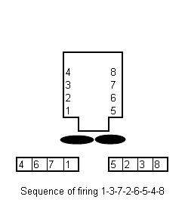
- Then the covers can be mounted over the cam wheels and the rotors and distributors can be placed. If you place new rotors or distributors: pay attention to the length of the bolts. By the way, the rotors only fit in one way. If a bolt doesn't go in, the rotor needs turning.
- Next you can mount bracket and clamps for the transversal spark plug cables, and finally the spark plug cables on the distributors. Make sure they are in the right order. You wouldn't be the first to misplace a cable.
- Then we put the frame of the alternator and the steering pump back in place and reattach the alternator.
- Finally the belts of the belt driven modules can be mounted. Of course we check the belts for damage or breaks. The AC comes first, then the steering pump, the air pump and the alternator last. Don't tighten the V-belts too hard, 2 cm pressure is fine. The belt of the alternator has to be quite tight. Press 1 cm in the middle is ok.
- We now arrive at the moment to fill up the coolant. Fill up slowly, and squeeze the hoses once in a while. If you have done everything right there will be no coolant running out of the pump. Some air remains in the system that still needs to purge, so you will have to refill later.
- Now you can reconnect the battery.
- And then the special moment ... we start the engine. Listen carefully if you don't hear anything crazy. Let the engine run quietly while you keep an eye on the belt through the vents above the belt wheels. It has to run neatly and nicely in the middle. Let the engine warm up. You will see that gradually more coolant is needed as air escapes. The system bleeds itself. Patience.
- Now we place the fans with the fan shroud. A little skewed is easiest. Then we have to connect the cable for the two fans and fix the cable in the clamps near the housing. The cable should not hang loose.
- Also fasten the strap that connects the lower water hose to the fan housing on the driver's side.
- Now put the steering oil reservoir back in place and fasten the hose clamp.
- Then we place the air hoses and the transversal connection. A short test drive. Take it easy, the belt still needs to adjust a bit. Stay below 3000 rpm.
- After the test drive we need to refill the coolant to the desired level. Check the belt again if it runs neatly in the middle.
- After 5000km the belt tension has to be checked. The belt stretches a little, and some adjustment is necessary. For adjustment only the cover on the pass.side needs to be removed. This can be done without removing the hoses and fans, but you will have few blue bruises and some scratches when it’s done
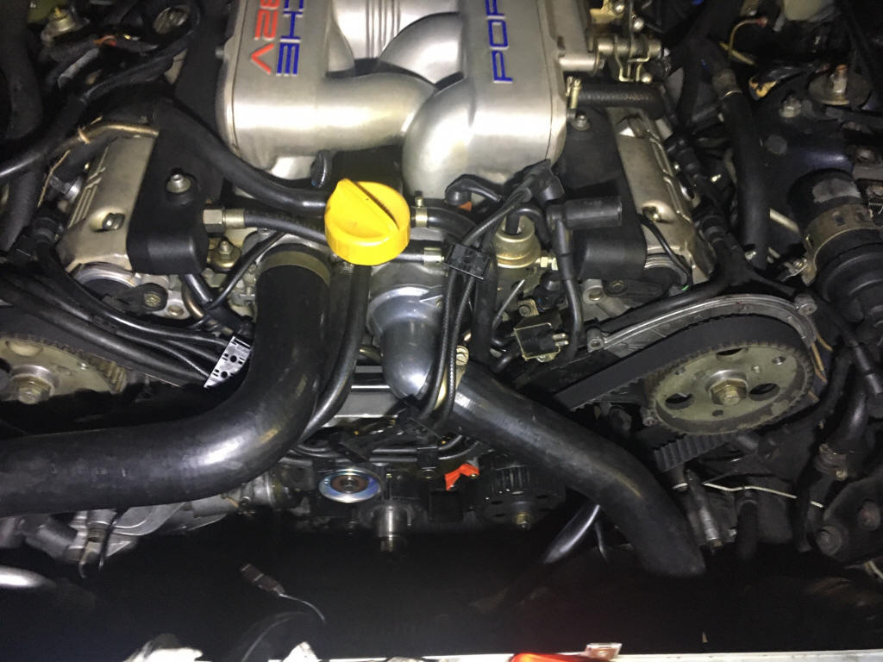
Job done!
==== // ====

