928 Tech Talk: Replace timing belt and water pump (S4/GT/GTS) part I
(by Theo Jenniskens)
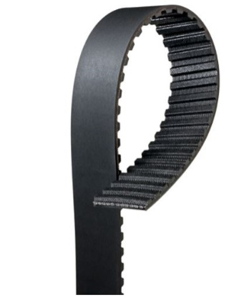
Part eleven in the tech talk series, and this time it's about major maintenance on the 928: replacing the distribution belt. It's going to be a long publication, so I'm dividing it into two parts. Now part 1.
The distribution belt of the 928 is a very long belt, also because of the V position of the cylinders, and in its length quite unique in the automotive world. The toothed belt is about 2.5 meters long, and there are two types, so pay attention. There are teeth according to the angular model which was used until 1983 and the rounder HTD (High Tension Drive) teeth as used from model 1984. Of course this means that the cam wheels that the belt runs over are also different. The description that follows is largely the same for the earlier 928 models, but I'll limit myself to the 1987 models and later, so S4, GT, GTS.
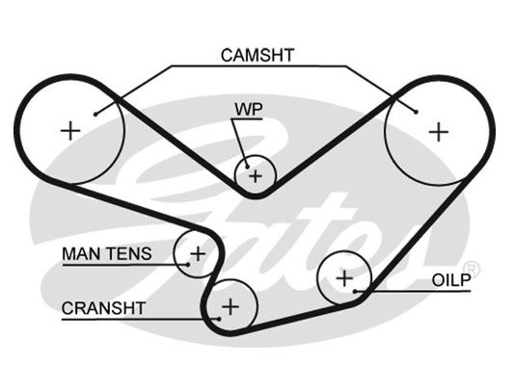
When to replace and why?
The belt needs to be replaced periodically. Porsche says the belt has to be replaced every 100,000 km but which vintage car now drives 100,000 km on the counter. There is a second aspect and Porsche is not clear about that. The belt is under strong tension and also stretches a little bit. The rubber becomes hot and cold despite not even being driven that much. So the condition of the belt deteriorates while it doesn't reach the planned replacement mileage. Consensus (and supported by specs from Contitech and Gates) is that the belt should be replaced every 6 to 7 years or every 60.000km. An expensive job that is often postponed or not done at all.
But there is more…..
The belt is crucial for the valve timing, but it also drives the water pump and the oil pump. The oil pump is actually a fairly problem free part that rarely needs to be replaced. The water pump is a different story. Tensioner and water pump run along the back side of the belt. When the bearings fail, the belt crawls off its place or the belt tension suddenly becomes too low. The water pump can also get stuck, which will put an enormous strain on the teeth of the belt.
What if I don’t replace it?
Well, you can light a candle in the chapel and hope for the best... The belt takes care of the timing between the camshafts and the crankshaft, causing the camshaft to move the valves down as soon as the piston is far enough away from the valve. If the valve opens while the piston is in the way, they collide and this damages the valve. It becomes bent and doesn't close anymore. The result is compression loss or even worse (broken off) and with it major engine repairs. The car doesn't have just one damaged valve, but of the 32, there are certainly a number of defects if the timing goes wrong. A belt that is too loose, or where teeth are bad, can jump a tooth, or even break. Damage is then enormous. The price you pay for the engine overhaul is a multiple of the belt replacement.
Immediately a big overhaul when changing the belt....
The belt seldom breaks just like that. If the external condition seems good and there are no cracks in the teeth, you might still think.... But if the belt tension is too low because the tensioner is stuck, or because the belt is stretched, or because the tension roller is worn out, or because the pivot point of the tensioner is worn out and has play that makes the belt run off the track, or because the bearing of the water pump has too much play... then there is a big chance that the belt will jump. And then there's another thing: if the water pump leaks internally, coolant runs into the bearing which can get stuck. This causes tremendous force on the belt, which can break or jump. Finally: the belt wheels also wear out a little. You recognize this because the new belt does not fit nicely on the openings of the cam wheel. The corners seem to be free so the belt only carries on a limited part. A careful inspection and perhaps replacement of parts is very important when changing the belt. Changing the belt is a big job and you don't want to loosen everything every year.
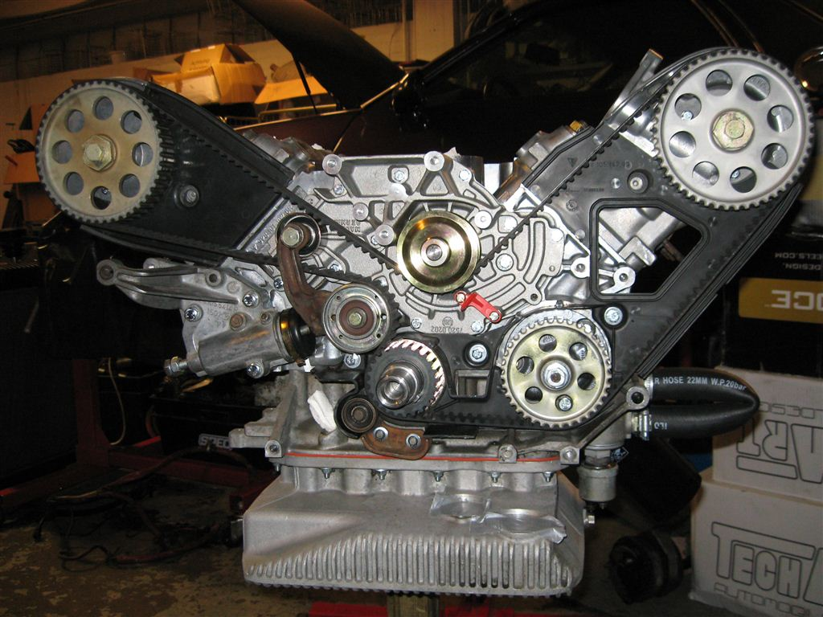
First sign of danger... my GTS in alarm phase red early November 2019 !!!!!
It happened on a Sunday evening in early November. The engine suddenly made a very abrasive noise. Sometimes very short and briefly gone, moment later it was there again. A quick inspection revealed that it came from the vicinity of the water pump. Then we took off the air hoses and yes, the belt ran much too far to the edge of the cam wheels. I turned off the engine and didn't start it anymore. The 7 year old pump is probably broken. A damaged bearing of the pump causes the pulley to be a little bit skewed so the belt runs another way. Just a little while longer and it will break down!
How much work is it and what does it cost?
If you are a bit of an experienced wrench-keeper, you can do it yourself at home provided you can lift the car properly so that you can safely get under it. It is about 2 whole days of work if you take it easy. Personally I like to work in phases, and I'm not in a hurry. Then you don't make any unforgivable mistakes. You'll quickly lose about 600E in materials, depending on what you're going to replace.
What do you need?
- Screwdrivers in types and sizes.
- - Ring, cap and/or socket spanners in various sizes
- - Deep 27mm cap with a long ratchet or extension of 75cm or more.
- - Torque wrench for 10Nm and for 300Nm. (desirable)
- - Coolant, at least 5L. 15L if you replace all coolant
- - If you replace dividers and rotors with two dividers and two rotors
- - Tool to block flywheel, tool to measure the belt tension
- - Timing calling Gates Powergrip of Contitech
- - Tension roller, possibly idle roller
- - Water pump with new galvanized bolts, washers and gasket
- - Ceramic grease for the bolts, and M6 tap end to clean screw holes
The step-by-step plan
- Ok, step 1 is to remove the bottom plate under the engine and under the catalytic converter. Just a routine job.
- Disconnect the crosslink above the engine and remove the air hoses.
- Take a picture of how straps are on top and how spark plug cables run. That will come in handy later
- Then you want to disconnect the battery. You have to work on the current, so you have to be able to work without the battery connected.
- You can now choose to drain the radiator. You can do this by removing the blue plug under the radiator. The alternative is to leave the radiator and drain the coolant when you disconnect the pump. In both cases it becomes a small pool under the car.
- The reservoir for the power steering will be in the way. Loosen the hose clamp and use a string or so to attach the reservoir to something so that it does not get in the way and does not hang upside down.
- Disconnect the air hose from the filter located in the center of the fan unit.
- Unscrew the two parkers that attach the fan unit to the radiator.
- Unplug the plug connections of the fan unit and remove the cable from the clamps so you can pull it all the way up. Place the cable somewhere on the pass.side of the motor so it is not in the way.
- There is a tie-wrap band on the driver side of the fan that holds the lower hose to the fan frame. You can slide it open and loosen it. (do not cut)
- Now the fan unit can get out. On its own the cooling hoses can remain in place, this way you also prevent leaks. It is easier if you take them away, but not necessarily. The unit comes out the easiest if you take it out askew.
- Disconnect the spark plug cables from the distributors. They are a bit stuck sometimes. Push carefully under the rubber, don't pull. Check for oxidation of the plugs, and work them out of the way.
- Unscrew the 3 bolts from the distributors and remove the distributors.
- Unscrew and remove the impellers from the rotors.
- Next we are going to loosen the spark plug cables at the front of the engine and the thick cable bundle that runs underneath. Try to keep bolts and materials together and if necessary label what is what. This can be quite handy
- We're gonna take the hood off the distribution belt. First on the left, some bolts, then on the right, some bolts. The pass.Side has a bolt in the middle that's not easy to fit. Make a note / sketch which length is in which hole.
- Then it's your turn to disconnect the alternator. The alternator and steering pump are together on a sub frame. The tensioner needs to be loosened and the suspension bolts need to be loosened so the dynamo can drop a bit. It stays on the crankcase so cables don't have to come loose. Also loosen the bolts of the steering pump so the belt can come off and the pump can move down with it. Mark that the belt is from the steering pump. Otherwise you will confuse it with the AC belt.
- On the other side loosen the AC tensioner and remove the belt. Also remove the belt from the air pump. That air pump is sometimes a bitch because it is hard to reach. It helps to loosen the 3x 10mm bolts and just remove the pulley. All the belts can now be taken off.
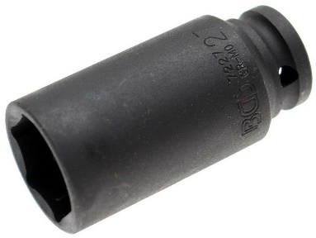
- You turn the engine with a deep 27 socket on the crankshaft bolt. Turn only in the clockwise direction. Don't turn backwards. You risk the belt jumping somewhere because the tensioner will be pushed too far. Since there is still compression you will have to turn firmly and slowly. Alternatively, first remove the 8 spark plugs. Use a ½" version and a long ratchet. Put the socket on nice and straight so you don't damage the 27mm bolt unnecessarily.
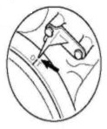
- We are going to put the engine on TDC first so that we can check later after assembly that the cam wheels are correctly positioned with respect to the crankshaft. Sometimes you see that there is already a color mark, sometimes not. The TDC position has two variants, the working stroke of #1 piston or the inlet stroke. When in doubt you can fit the rotor of the pass.side. It only fits in one way. If that rotor points towards the driver side, then the #1 is in working stroke. Mark the TDC position in the middle on top of the belt wheels compared to the marker on the housing. This position will also be important when measuring the belt tension.
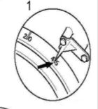
- Now we are going to set the engine to 45 degrees. In that position the pistons are in such a position that they won't touch the valves. Also mark this position on the cam wheels. Later you want to put on the belt in this position. If the cam wheels turn, they should be turned back in position.
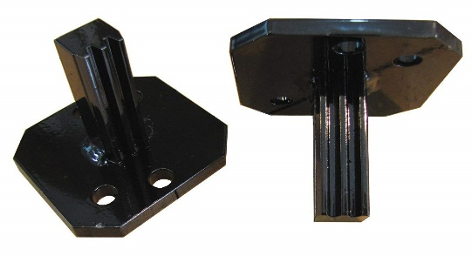
- Now you have to lock the crankshaft. This is to prevent unwanted rotation and also because otherwise you won't be able to loosen the crankshaft bolt. Unscrew the cover plate at the flywheel (2x 13mm bolts) or if you have a manual car remove the clutch cylinder. Place the lock on the teeth and screw it tight with the 13mm bolts. The engine can't turn anymore.
- We are going to unscrew the crankshaft bolt. It may take a lot of force. Think 250Nm or 300Nm. Eventually the bolt will loosen. As soon as it does, check that the crankshaft and the cam wheels have not turned. Then the bolt can be removed, the belt pulley can be removed, and the AC pulley can be removed. Now you look at the vibration damper with the 45 mark at the pointer. This damper has to come off.
- If you can get the damper off with a bit of twisting and turning, that's fine. Sometimes it is stuck. A big pulley puller can help (carefully) or warm up the alu silencer around the crankshaft with a heat gun. As soon as the silencer is off make sure you don't lose the wedge on the crankshaft. Check if the inside of the silencer is not oxidized and clean it carefully, just like the crankshaft itself. Also remove the protection plate so you can see the timing belt running around the crankshaft.

To be continued...
==== // ====

