This document is a bundle of doorlock re-keying procedures for Porsche 928.
Inhoud
PORSCHE 928 HATCH LOCK REKEYING PROCEDURE 1
The Anatomy of a Hatch Alarm Lock 28
Re-keying Porsche 928 Locks 37
Hatch Lock 37
Door Locks 39
Petrol Cap Lock 42
PORSCHE 928 DOOR LOCKS PROCEDURE 43

PORSCHE 928 HATCH LOCK REKEYING PROCEDURE
Rekeying 928 Locks Procedure by Wayne Strutt
Here is a tutorial I put together to help with lock rekeying. I have learned a great deal from this forum so maybe this small contribution many of you will find useful.
This is my experience rekeying my hatch lock. Since I did not have a key that would unlock the hatch I did as suggested on the 928 forum.
First, from inside the hatch, I drilled a ¼” hole in the body frame about ¼” down from the top edge of the hatch in line with the lock receiver. Then, with my shoulder pressing against the inside of the hatch glass, I pushed a screw driver through the hole and released the lock and opened the hatch.
For cars with keyed alarm if you look overhead you will see a number of cap retainers that hold the finish trim to the inside of the hatch. These are 2 piece. Use a thin screw driver and pry the centre cap straight out. The piece remaining can be removed using pliers to squeeze the split together and pull out of the hole. Now pull down the trim to reveal the alarm wire harness. Unplug the alarm wires.

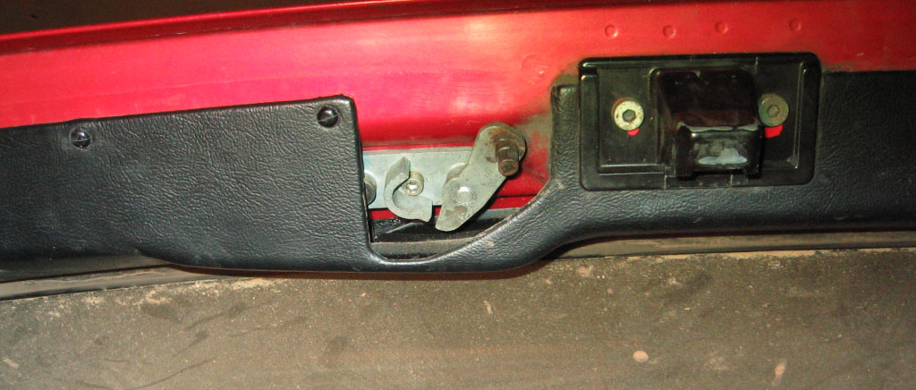
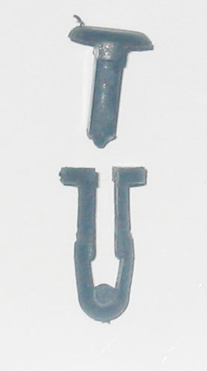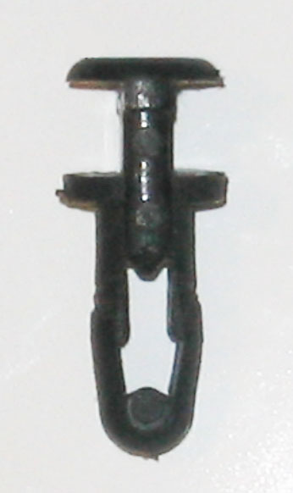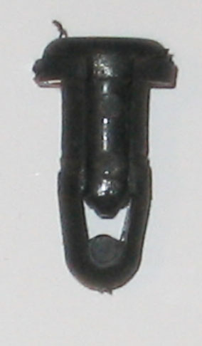
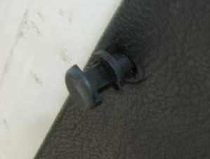
TRIM FASTENER
Using a 5 mm hex key allen socket unscrew the 2 , 10mm long hex drive capscrews that hold the lock bracket to the hatch door.
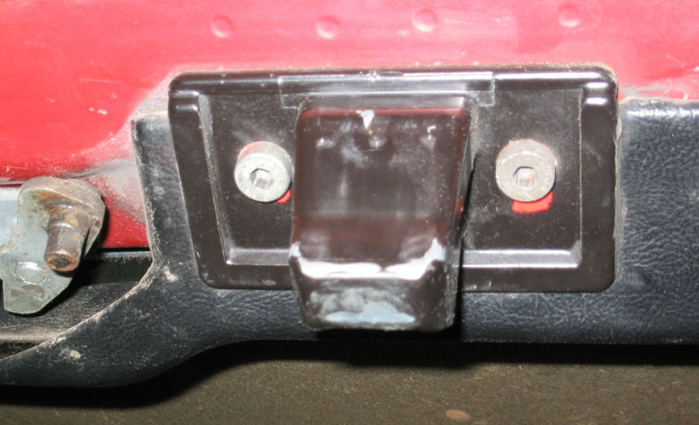
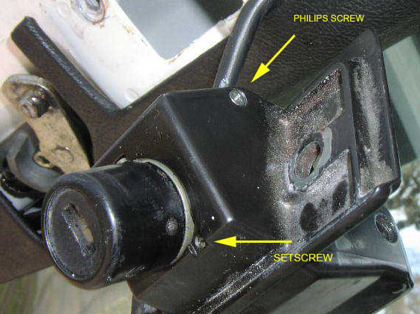
You now have in your hands a lock in a bracket (Alarm lock will have a wire with plug connector coming from it.) Go inside now. 9 below zero makes your body shake too much to handle the tiny parts from here on.
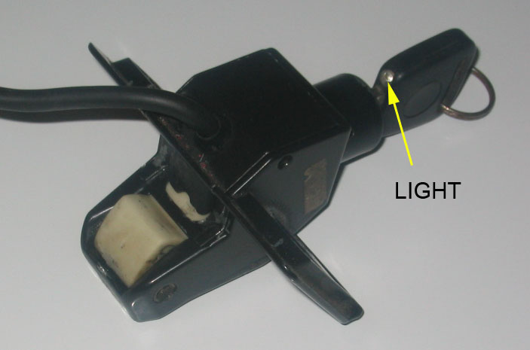
I have indicated the light for orientation as that would be the way you would normally insert the key.
Also from here you need:
a spring loaded Centre Punch,
A Drill
some Verrrry Sharp Drill Bits , 1/16” and 3/32” to get the cap off the Barrel
no 35 or 7/64” drill bit, for the 6-32 Tap ,
1 set of small Screw Drivers (Philips and Slot)
Cleaning Solution (paint thinners)
small paint Brush for cleaning
Tweezers
Masking Tape and
the largest Bedsheet you can find for when you drop one of the tiny springs .
and ………..Patience
On the sides of the bracket are small flat head Philips drive screws. Remove these and separate the underside portion of the bracket from the main part. With an alarm just move it out of your way as the wires run through it.
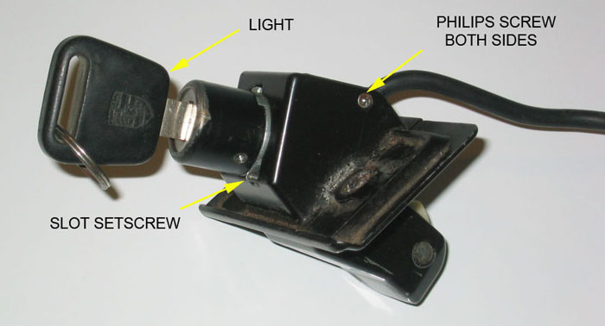
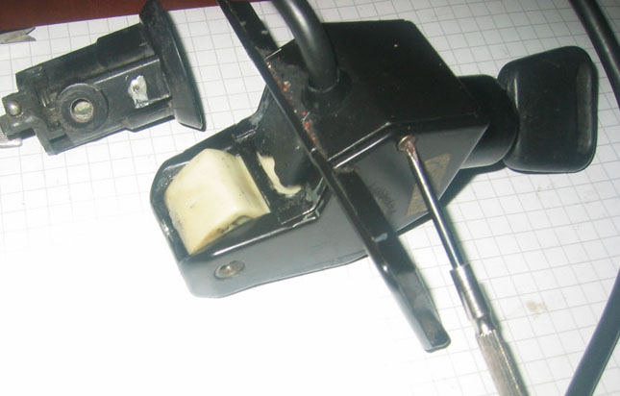
If you have an alarm lock you will see a black plastic cap. Pry that off.
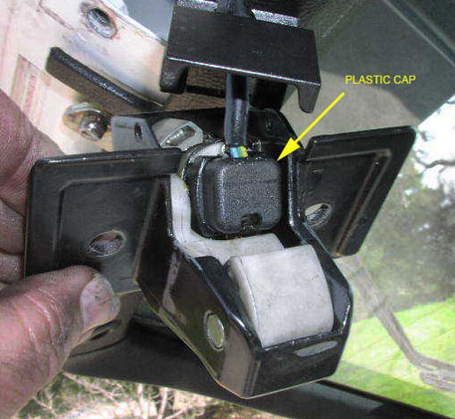
Remove the two small Philips screws that hold the plastic wire carrier to the barrel. Lift this off and you will see a copper contact finger. Remove the plate and rubber sealing gasket. Note and mark the position of the copper contact finger with the barrel, as it is important on reassembly that the contact finger moves from one copper contact to the other. The copper finger on the end is fragile.
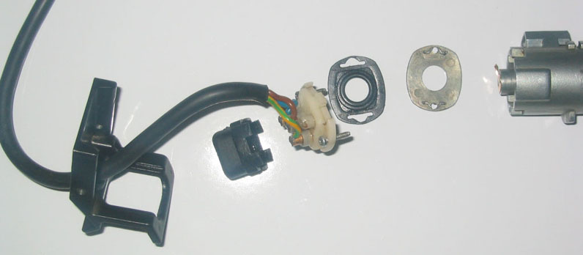
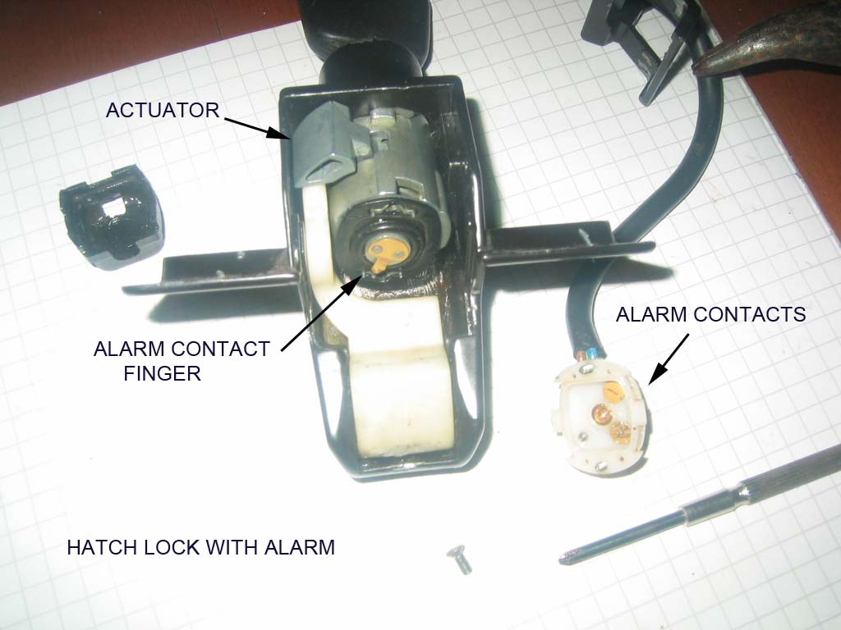
Now on the key entry side is a small flush slot head setscrew next to the barrel. Unscrew that to unlock and allow the barrel to rotate in the bracket counterclockwise. Line up the boss with the hole in the bracket. Push the barrel into the bracket to remove it from the bracket. Remember the copper contact. Hold the white plastic lever down to slide the barrel out without hitting the copper contact. The actuator on the side of the barrel will hinder this but it can be done.
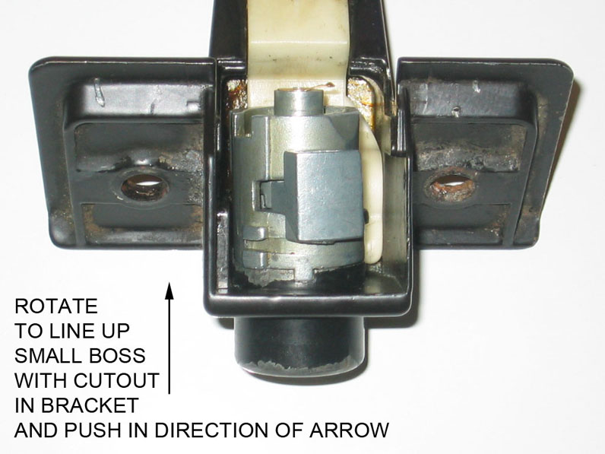
The barrel will have to be drilled on both sides to get the cap off. Centre punch a starting point and drill with a 1/16” (1,5mm) bit approximately 1/16” (1,5mm) deep. Stay centered,the bit will want to wander to the softer diecast zinc alloy barrel. Then using a 3/32” (2,4mm) bit drill to the same depth again. The cap is .05'' (1,27mm) thick and the barrel is 1/8”- .125” (3,175mm) thick at this point. However if you drill more than .175 ” (4,45mm) deep you will hit the core and ruin the lock. Later what is left of the pins will just push out of the barrel.
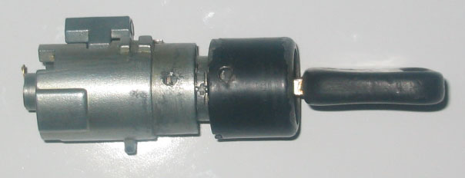
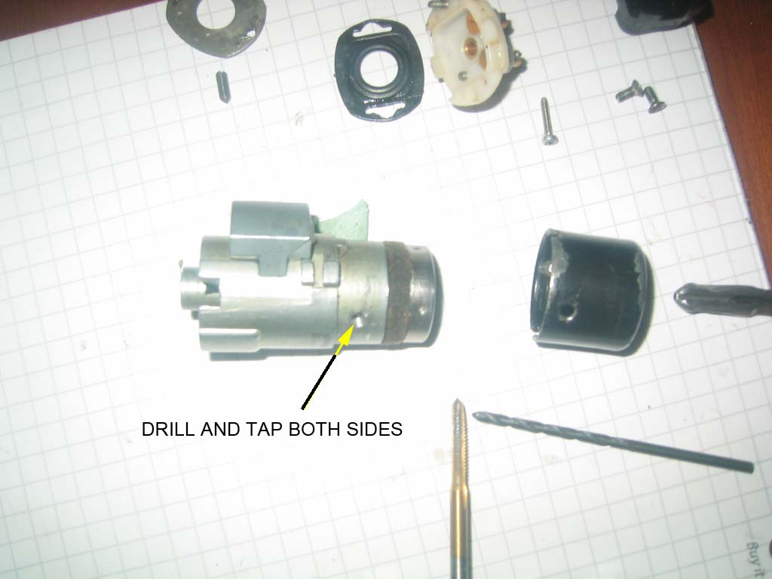
When you take the cap off make sure the core stays in the barrel. Use a thin blade and pry (ease), the cap off. Then REINSERT the key. I think the best way to restore the unfortunate need for drilling is to tap the barrel holes and install set screws or maybe cut off roll pins. But they only need to be about 3/32" to 1/8” long. Any longer and you will hit the core and prevent rotation.
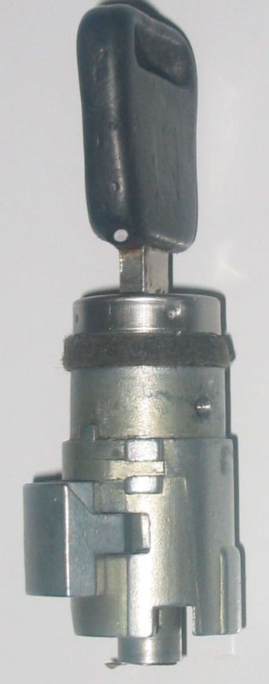
Vehicles with factory alarm will have a longer key, which adds 4 pins to the basic 10. When you take the core out of the barrel make sure you keep the key in it or everything will fall apart and you will have to find the small springs that are released. Hold the barrel vertically, key on top and pull the core up slowly out of the barrel. Place the core aside key still in it. and look inside the barrel. Observe inside the barrel the 2 ridges opposite each other.
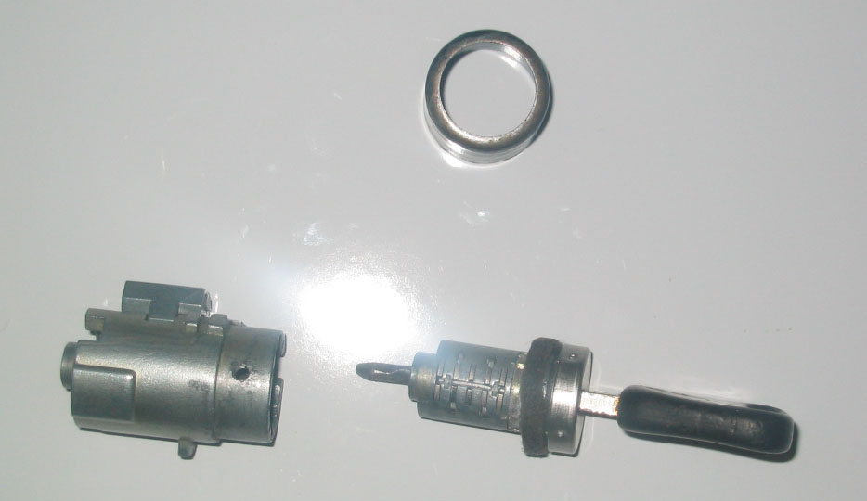
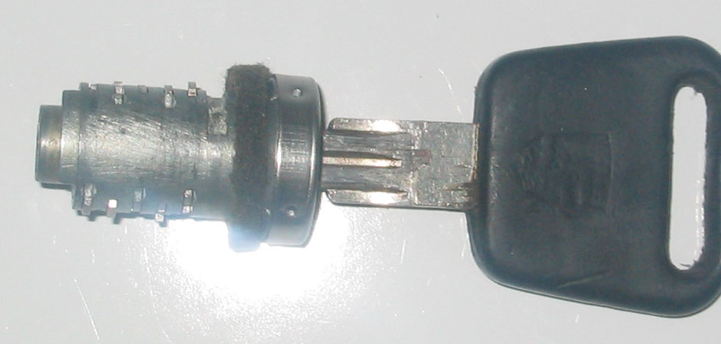
Do not let the actuator lever on the outside of the barrel move, or let the large spring that operates it come out. Observe and note where the ends of the spring are located as this spring returns (rotates) the actuator back to the lock engaged position. Slowly move the actuator and see how it works. Now this can be removed and cleaned. With the spring released the actuator will remove out the side of the barrel. The alarm core can now be dismantled for cleaning and rekeying.
Note the position of the core and barrel relationship, as the key will only operate the lock at a specific point. Mark the barrel (scribe a line in line with the key.) It is possible to install the core 180 degrees out of position.
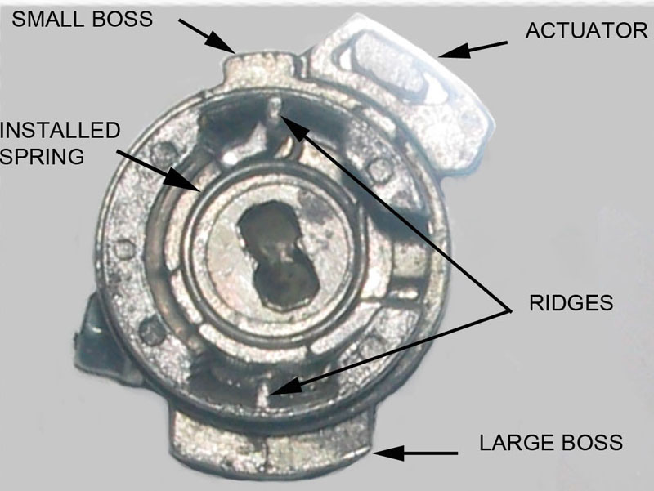
Barrel with alarm core, actuator, and spring
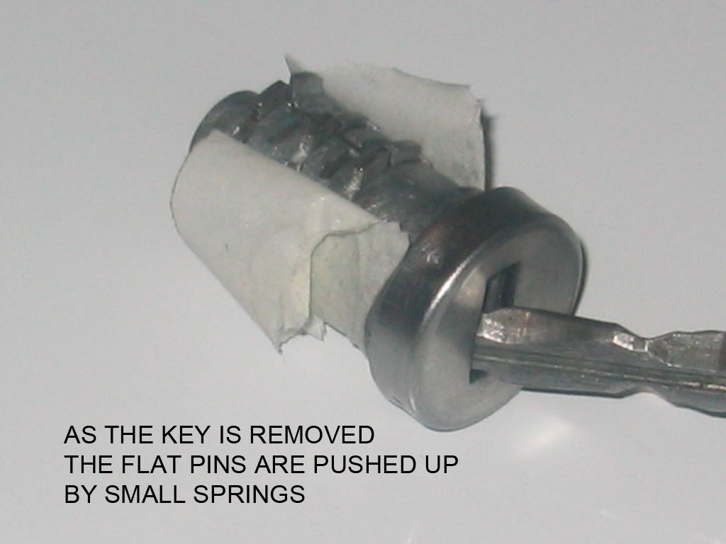
With the core and key assembly out of the barrel hold the core HORIZONTAL and, with the key handle VERTICAL. Wrap masking tape around the bottom half of the barrel. Slowly pull the key out of the lock core. Stop at ¼” and observe how the row of pins (as the springs push them up) form a groove. Remember above, inside the barrel the 2 ridges 180 degrees opposite each other. The pins will be located on each side of this ridge on reassembly, top and bottom.
Now (over the large bedsheet) remove the key, and, using tweezers remove the flat pins, or blades note the number (make a chart to record the location) . Below each blade pin is a very small spring. Do not lose them. There are 6 pins on the bottom and 4 on the top. With the one side empty turn the core over and remove the tape and repeat the pin removal noting again which number went where. The top has 4 pins the bottom 6 when lock is installed in hatch or door. Clean everything and reassemble with a wipe of light oil or lithium grease. If rekeying a lock start with everything clean and laid out. i.e. groups of pins according to numbers etc.
Back to the clean empty barrel: Push the remainder of the drilled pins out of the barrel. I chose to tap the threads 6-32 and use set screws from HD sku 2241200884. They are a bit long and need to be shortened. Buy extra it’s cheaper than the gas to go back for more.
When tapping the barrel ensure the cap is on so you tap both together. If you find an allen key that fits the screw let me know. Alternative: just thread the barrel, then on final assembly run the screw into the barrel, put the cap on and then back the screw out tight against the inside of the cap, locking it. I would use a drop of cyanoacrylate on the screws. The screws only hold the cap on .They do not hold the core in the barrel as is the case with the door locks. Deburr the inside of the barrel at the tapped holes.
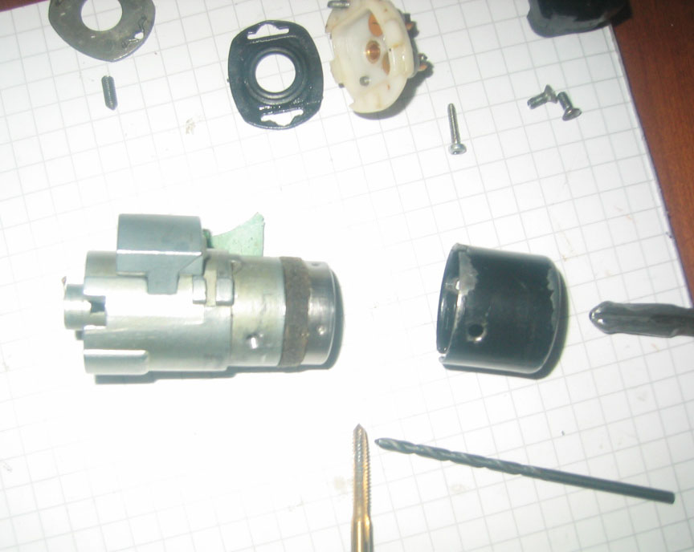
INDEX OF PARTS
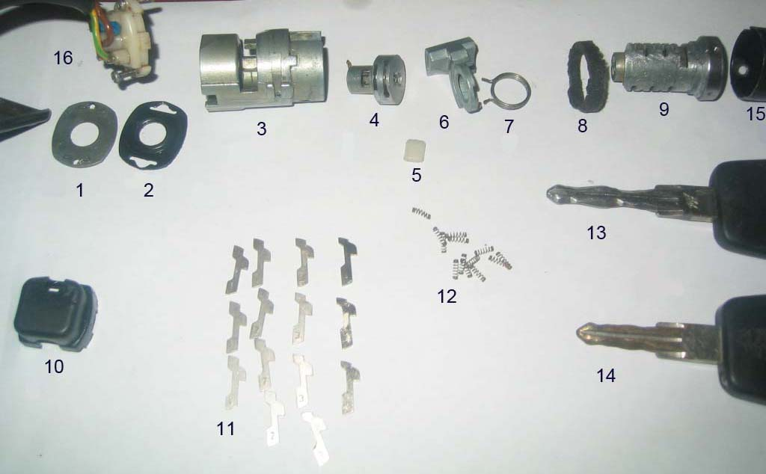
ITEM DESCRIPTION
1 Alarm contact isolation plate
2 Neoprene moisture seal
3 Lock barrel housing
4 Alarm core with contact finger
5 Nylon bearing
6 Actuator
7 Spring
8 Felt seal
9 Lock core
10 Alarm wire cover (plastic cap)
11 Flat pins( numbered 1 to 4)
12 Springs
13 Alarm key
14 Nonalarm key
15 Barrel cap
16 Alarm contact wire
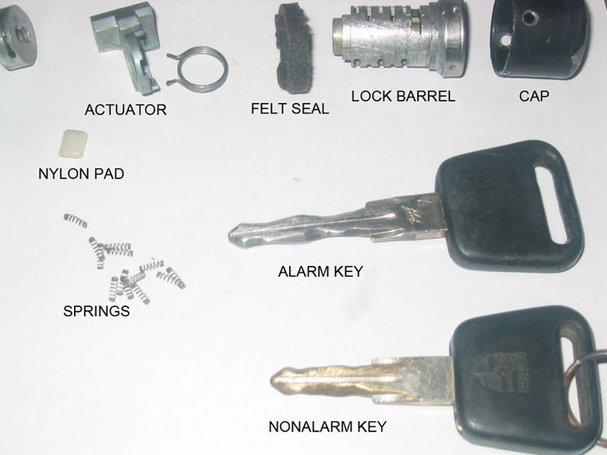
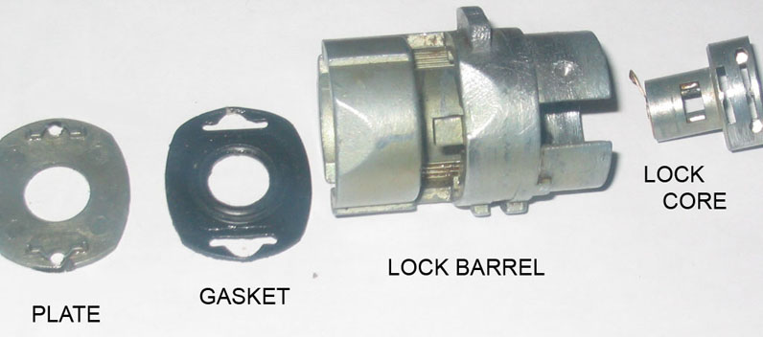
Additional pictures for reference only
REKEYING
Using tweezers place a spring and pin in the first hole then insert the key. If the pin is flush with the surface of the core, good, if on the side installed it sticks up (IS HIGH) go to the next Higher number, if too LOW the next LOWer number. When the one side is done place tape over the pins and turn the lock core over. Repeat the process noting which number pin went is in which slot on a chart. This chart will allow you to rekey the other locks to the same key much quicker.
If you have an alarm lock you will have 2 more pins on each side to deal with. The core for the alarm is done the same way but on reassembly must be installed first, separately from the main lock as the actuator goes in between. The key is used as well but you must put the main core on the key so that the alarm section is held at the correct position on the key for determining the correct alarm pins. In other words do not try to set pins for alarm section without the main core on the key Remember above how it was dismantled. The small alarm core with the copper tab must go in the correct way (pointing right) for the tab to touch the copper pins in the white nylon wire carrier when the key rotates it.
In summary : there are 4 different cut pins numbered , 1,2,3,4, plus no pin giving you 5 choices for each of the 10 main slots and 4 alarm slots.
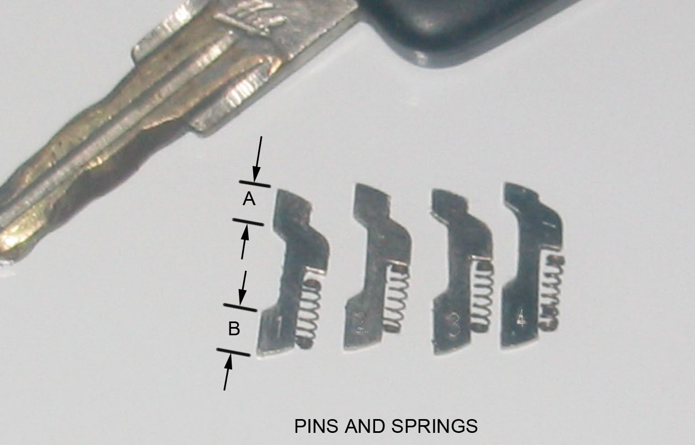
NOTICE HOW DIMENSIONS “A” AND “B” VARY FROM PIN NUMBER 1 TO 4
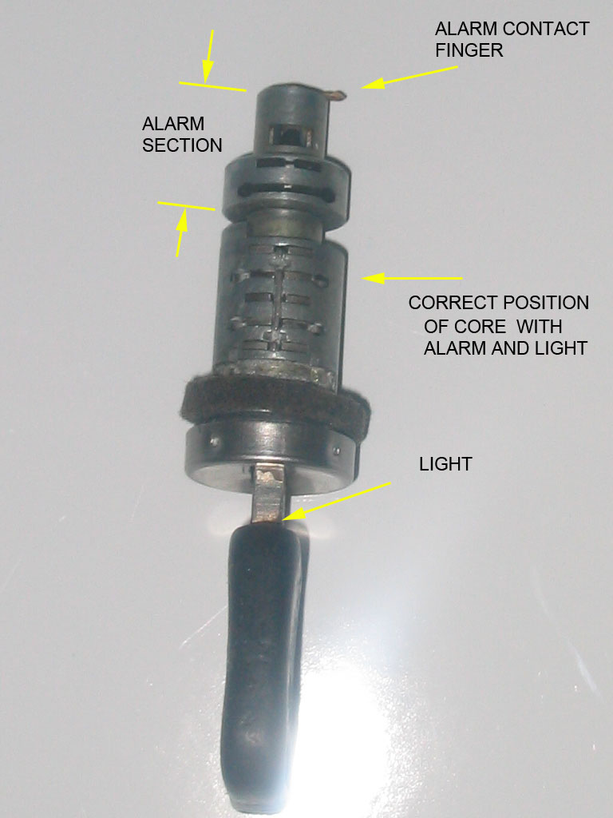
This is the correct position for setting alarm code pins.
Without main core on the key the alarm core will move closer to the key handle,
and will change what the correct alarm code pins need to be. It is possible to install the core 180 degrees wrong which is why I have stressed, key, core, and barrel orientation.
The main core has 4 pins on the top side as shown above,( light on top and alarm contact finger pointing right.) and 6 pins on the bottom. The alarm core has 2 pins top and bottom.
MAKE A CHART
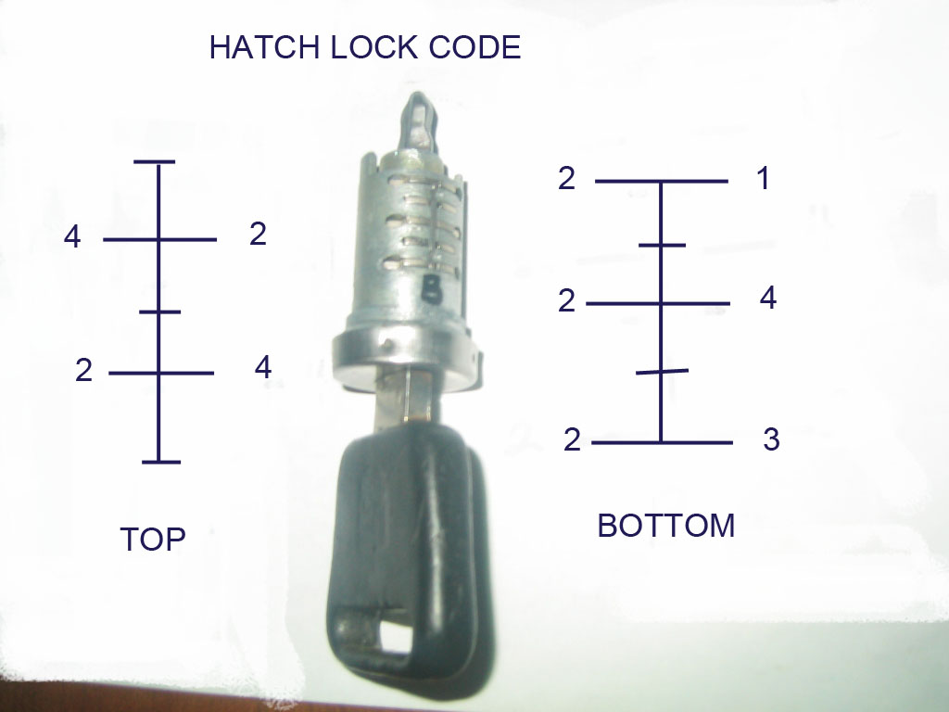
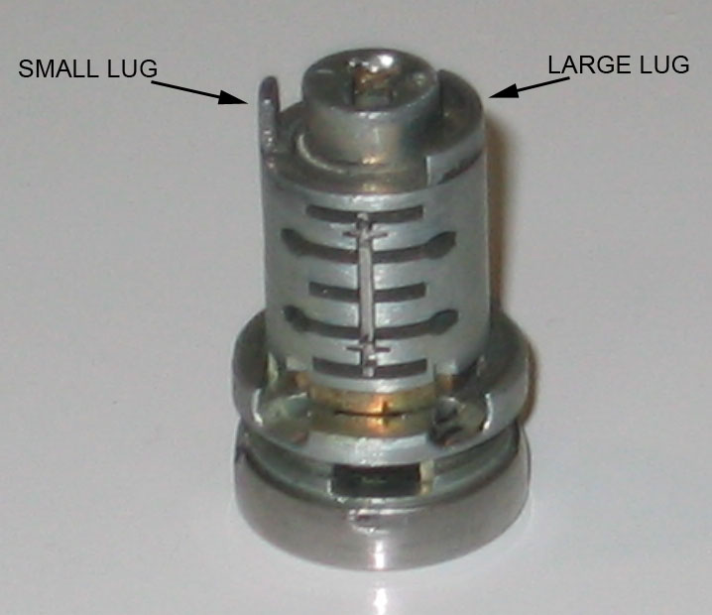
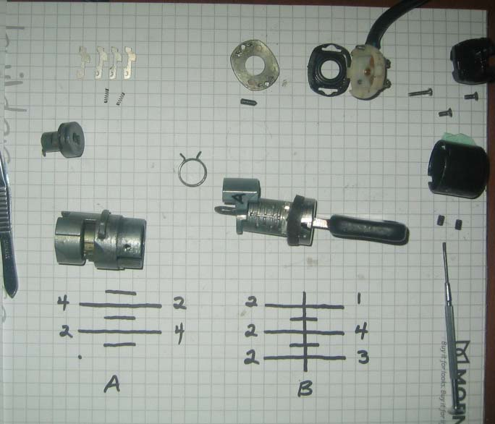
Clean again and assemble the core beginning with the alarm core then the actuator and large spring then the main core, using lock lubricant or lithium grease.
Remember the orientation of the barrel in the bracket, with the ridges and the groove created with pins. Hold the barrel with the casting boss that locks into the bracket, on top. The alarm core goes in with the contact tab pointing RIGHT. Use the key to insert this, then remove key. Without the key only gravity is holding it in so, the barrel must now remain vertical.
Slide the actuator in the side of the barrel. Hold it counterclockwise. You are now looking down into the barrel as you struggle with the spring. Amazing how such a simple part can take so long to install.
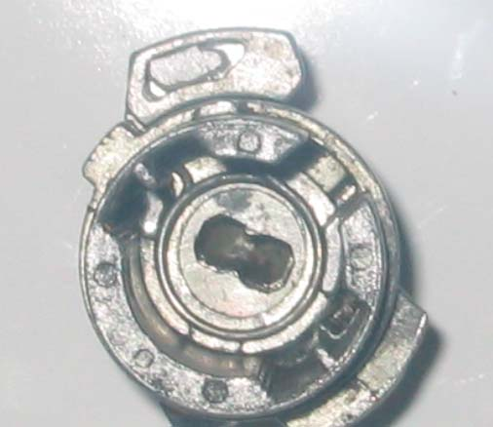
The actuator has a large flat radius base on which the spring sits. Do a trial fit to make sure you have the spring returning the actuator counterclockwise.
Holding the Barrel with the SMALL CASTING BOSS ON TOP, and THE KEY VERTICAL, LIGHT ON TOP, install the core so that the Small Lug is on the Left , and Large Lug is on the Right.
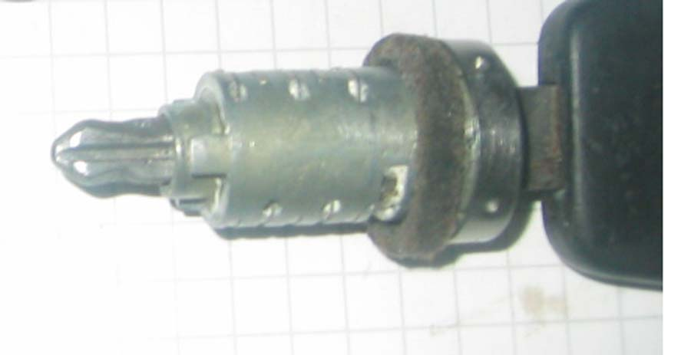
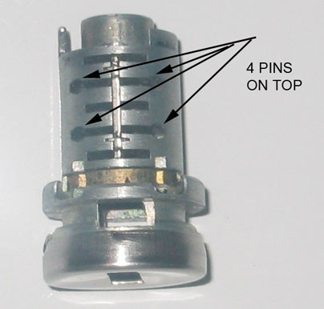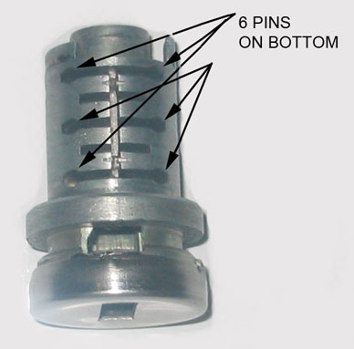
If horizontal the core will have 4 pins on top 6 on the bottom. This is how it should sit in the barrel and the actuator. The key turns clockwise to open so the core must fit into the actuator so that it will turn the required amount.
If the movement is smooth replace the cap and insert set screws. Install in bracket. Reassemble the other end of the alarm system. When installing the neoprene gasket and metal plate (items 1,and 2 in index of parts) put no strain on the copper finger. You will now have a lock that is ready to reinstall
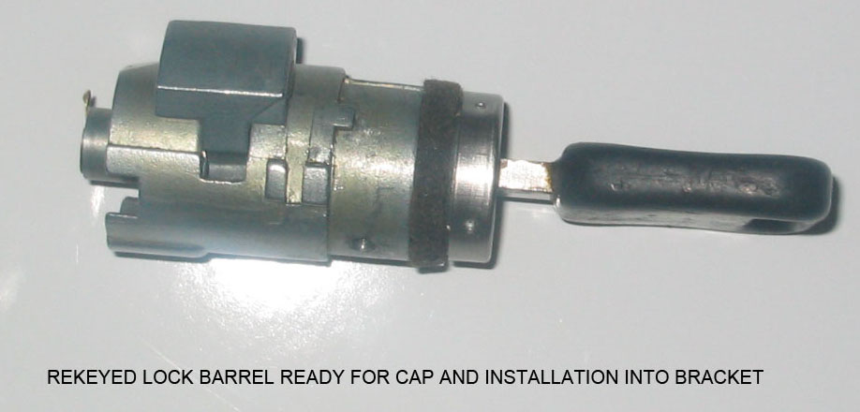
On assembly I used dry lube p.t.f.e. spray on the pins and white lithium grease in the barrel... Good luck.
Throughout I have not used the term “tumbler “as nothing tumbles. The key is machined with a symmetrical wave pattern. It simply aligns different pins against the tension of small springs to permit the centre core to turn inside the barrel. When the key is removed the springs push the flat pins up, on each side of the top and bottom ridges preventing the core from rotating inside the barrel.
I would also advise against filing the edges of the flat pins as doing so, you will create a lock nearly impossible to duplicate. Rather leave them standard and omit both spring and pin if none fit. Recording the standard numbers (code) will allow future keys to be cut and locks to be rekeyed that will fit the rest of the car.
I would also like to acknowledge that some of the pictures and information used here was garnered from others on rennlist, I thank you. If you have any questions or find this vague or incorrect please contact me and I will make the necessary changes.
GAS CAP
The Gas cap has no metal lock barrel retainer and will need no drilling. Inside the cap between the red and white sections are three molded plastic retaining flanges, (on the red part) that lock onto the shoulder of the white center section. Warm the red portion with hot water or a heat gun until the flanges are flexible, and, using three hands and 3 flat blades, CAREFULLY force back the tabs while pushing on the key to press the white section out of the red cover.
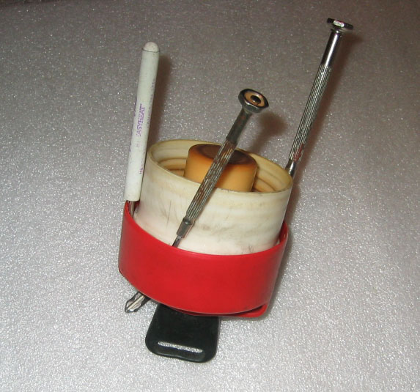
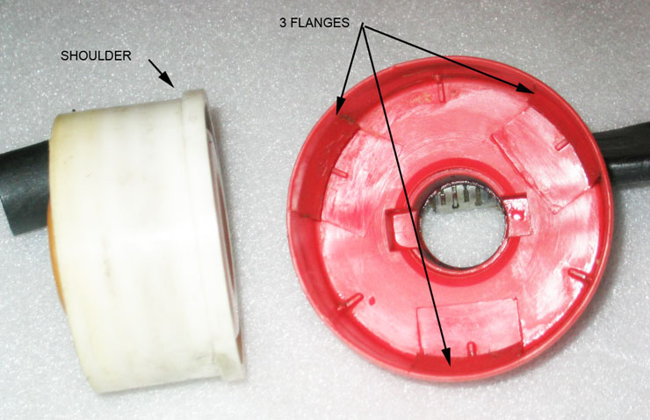
Now the black plastic lock barrel assembly can be removed from the white section, carefully as there is a white plastic ratchet pawl that is spring loaded inside the end of the black plastic barrel.
This locks or unlocks the outer red cap to the inner white section and makes the ratcheting sound when the locked cap is turned.
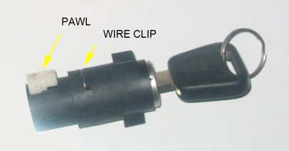
Just up from the spring loaded button is a wire clip inserted in the side of the black barrel which holds the core in place. Remove that with a small screwdriver.
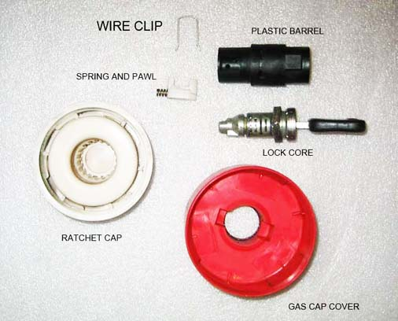
Insert the key and pull the lock core out of the black housing.
Insert the key you want to use and rearrange the flat pins to suit as outlined above. Remember there is a tiny spring under the shoulder of each pin. Don't lose them. When pins are done lubricate, slide the core into the black barrel, and insert the wire locking clip.
On reassembly, you have to squeeze the spring loaded button to get the cam on the end of the black barrel to engage in a slot in the white section. When complete simply line up the black barrel rectangular body with the rectangular recess in the red outer cover and press the red cover back on and you are finished.

The Anatomy of a Hatch Alarm Lock
By Bill Ball
I was complaining earlier today and asking for help with a hatch lock that would unlock but not lock the hatch. It simply would not turn in the counterclockwise direction. Here is what I found on dissection.
First, here is the hatch upper latch mechanism removed from the car and partially disassembled.
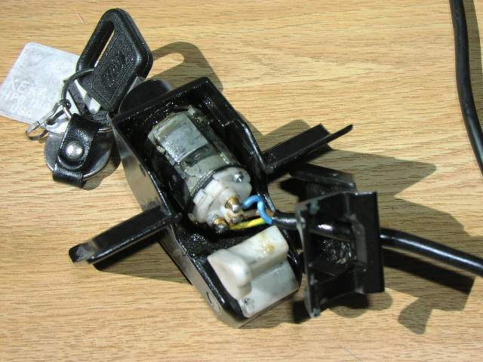
Below is the detailed anatomy of the lock. I don't show how to disassemble it, but I will just say you have to first remove the tongue from the latch housing by drilling out the flared end of the pivot pin to get the lock out of the latch housing. Then drill out two tiny pins you will see in the lock's black dress ring. This is somewhat hard due to the tiny size of the pins but I managed by bracing my Makita and going at it. The dress ring is a tight fit even with the pins drilled out. Once that is off, put the key in, and the tumbler will slip out.
What I didn't see even after removing the alarm contacts, gasket and base plate, was the alarm lock tumbler - the source of the problem. It was hidden in grease inside the lock. It has two additional blades.
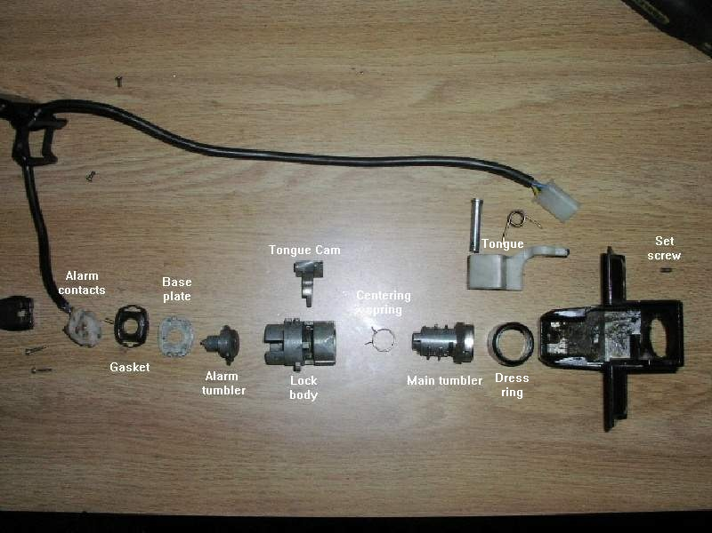
This shows what should happen when a key goes into a tumbler - the blades or whatever they are called are retracted flat with the tumbler surface so it can turn in the lock barrel. This is the main lock tumbler - it works fine. What about the alarm lock tumbler?
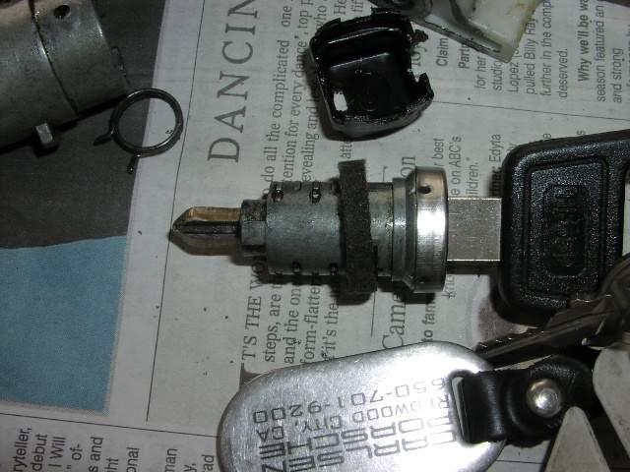
I cleaned out the grease and fiddled with the alarm tumbler and key. It was stuck in the lock body, but finally came out. Here is why it would only turn one way. One of the blades stayed proud when the key was inserted due to wear to the other side of the blade inside the lock.
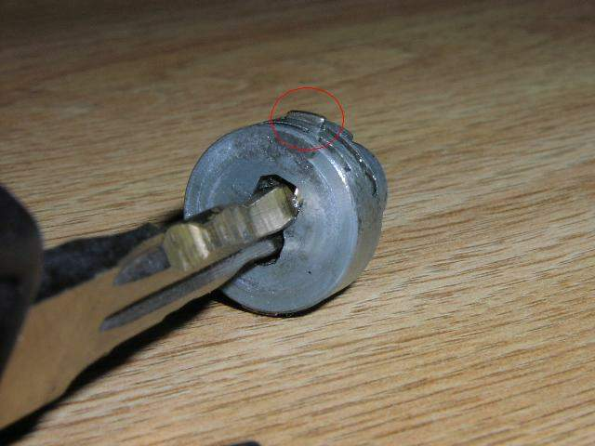
Earlier I mentioned the passenger door lock exhibited the same behavior. Here is a photo of the end of the lock with the alarm electrics and base plate removed and the grease cleaned out. Note the two blades locked against the lock barrel. THIS IS A DOOR LOCK, not the hatch lock, so don't let that confuse you, but it illustrates the problem with blades that do not fully retract flush due to wear. The green arrows point to the two blades capturing the boss on the inside of the lock body so the lock will not turn. That's good with the key out.
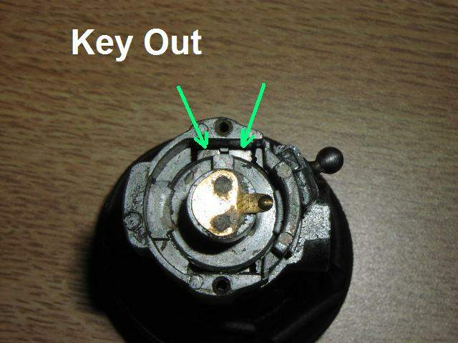
Now look at the lock with the key inserted. Hah! One blade did not retract fully. So, the lock will turn one way (opening the door) but not the other (locking the door).
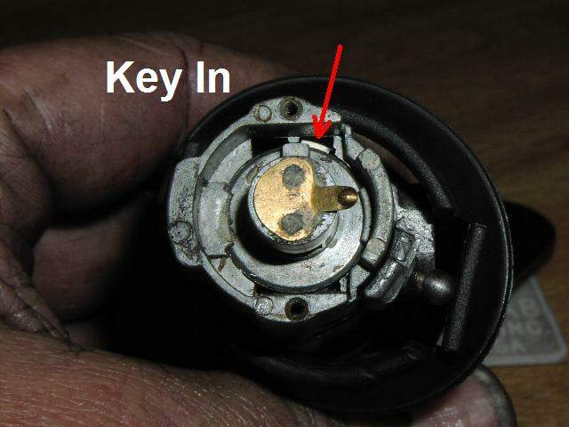
The solution is to take the lock apart and file down the protruding blades.
Here is why the hatch lock would not disable the alarm upon opening the hatch even though the key turned easily in that direction. These are the alarm electrical contacts that fit on the end of the lock body, shown here AFTER I cleaned them up. One of them is badly eroded. However, it did work after the clean-up.
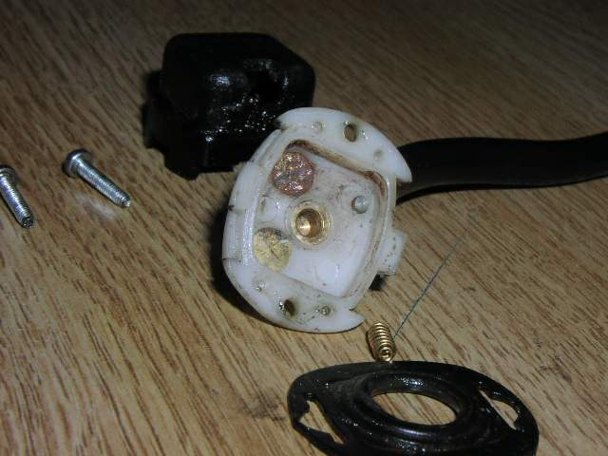
Here are the door lock electrics - CLEAN. It still disabled the alarm as it should when opening the door.
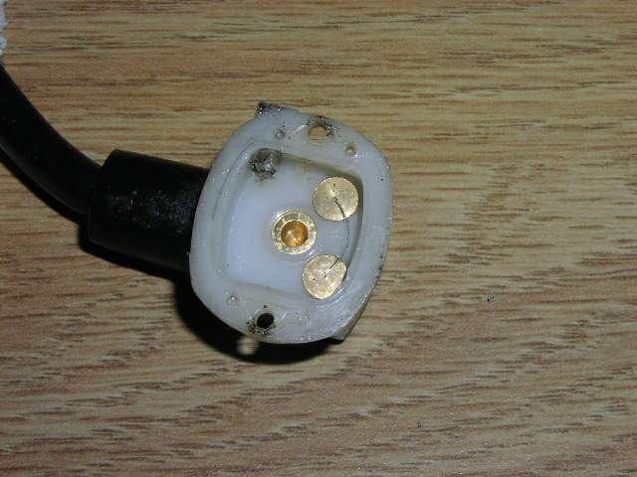
It took filing of almost every blade to get the action to be smooth, not just the one obviously high blade. The others almost all had high edges that caught on the inside of the lock barrel. The tolerance inside the door and hatch locks are much tighter than in the gas cap lock. It did not require nearly as careful or complete filing. For the door and hatch locks you want not even the slightest edge of a blade protruding, so remove them and file them so they are very slightly below the tumbler face. Check with the key in both ways. Check with the some turning force on the key in the tumbler to make sure the blades do not cock slightly and protrude as you turn the key.
Aha! I was puzzled by how the spring goes in. It finally dawned on me after some trial and error.
Here are the parts: tumbler, spring, lock barrel
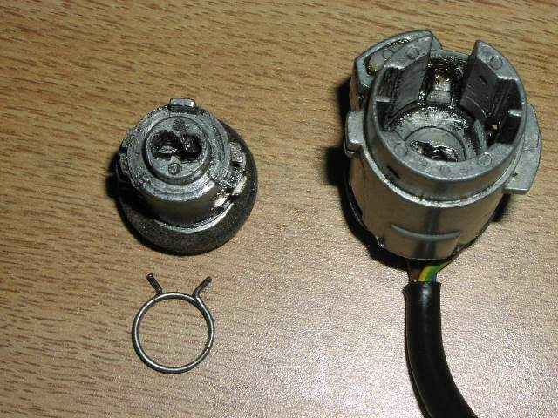
Here is the spring just layed in its location on the tumbler for starting the install. It needs to be wrapped around the post so that the tang pointing right ends up on the other side of the post, putting tension on the spring.
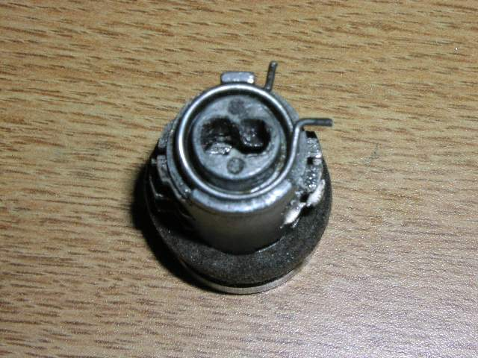
Here it is wrapped around the post:
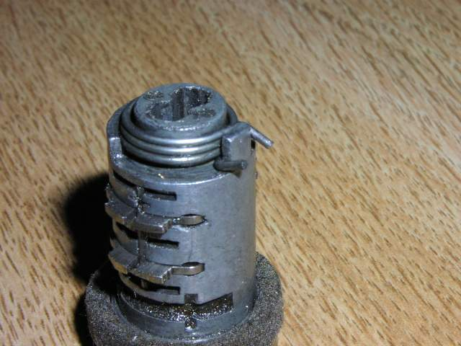
Finally the tumbler is installed so the post goes in the center of slot in the lock barrel. The spring tangs will engage a similar post inside the lock barrel in the center of the slot.
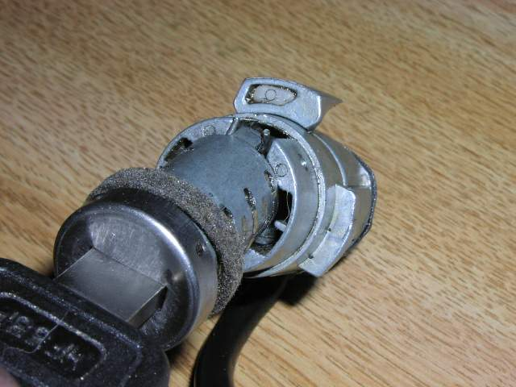
__________________
Bill

Drilling out the Pin:
The pin that holds everything in place is a simple drift pin. There's no way to get behind it, so it has to be drilled out. Unfortunately, the pin is harder than the cylinder body. Drilling it is a pain.
When I did mine, I simply tapped the hole the pin goes in and put in a little setscrew. I took a normal screw, cut it off and cut a slot in the shaft. Little bit of blue locktite to hold it in place and it was good.

Re-keying Porsche 928 Locks
Nick Carrington, Gareth Croeser, Jon Holdsworth, November 2002

Hatch Lock
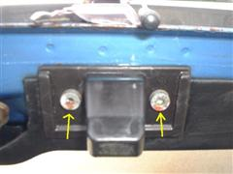
Procedure is moderately "involved" for the hatch lock. I'd assume more involved for the ignition! Anyone with some reasonable mechanical ability can do this - really. - It takes about 3 hours the first time.
Note: Some portions may slightly differ for the main key.
- Remove the two Allen screws and drop the lock out of the hatch.
- Remove the mechanism to a work bench (strongly advise using a large, clean surface on a towel – as there are small parts).
- Drill out, or otherwise remove, two pins holding the cylindrical cap on the top of the lock and remove the cap, thus revealing the top of the lock barrel.
- Drill out, or otherwise remove, two pins at the sides of the lock at the top of the sloping cover. Remove the cover exposing the plastic cam mechanism underneath.
- Drill out, or otherwise remove, the pin in the side of the plastic cam. The cam will now slide off the end of the lock barrel.
- Put your WORKING key into the lock... If you don't, the whole thing freaking falls apart all over your garage! (Voice of experience).
- Slide out the mechanism from the housing, with the key inside. You will notice that there is an additional lock part that may or may not have come along as you pulled out the mechanism - This is the alarm-activating portion. You are now free to re-key.
- Re-keying: The basic idea of the lock is that there are several "slides" that all align (with key inserted) to make the cylinder spherical. The slides look like with key removed, the slides drop into two grooves on opposite sides of the housing to prevent the lock from turning. Each slide slides into the cylinder from only one side, and have a spring that pushes them into the grooves in the housing with the key removed.
- Each slide has a number on it. As you remove them, jot down the number on a note pad in case you want to re-assemble it as you found it.
- Slowly pull out your old key, holding the slides from utterly popping out - the springs only push SO far, so no worries. . .
- Put in your new key and note which ones (if any) align properly now. The rest simply need to be switched around until they DO align. They have to be switched with the key out, so repeat #2 above until you are close to done.
- OK - so you have two or three that just won't align?? Get out your flat file and convince them to align.
- Do the same with the additional two (?) slides in the alarm portion of the lock.
- Prepare the housing to re-assemble by going to your hardware store and getting two standard brass tumbler pins a size or two larger than your old pins. (You get these from the person who re-keys home-locks.)
- Put the collar on the EMPTY housing and drill your new (larger) holes into which you will nudge (not smash) your new brass pins. Try not to drill all the way through - it's OK if you do, though.
- Put the whole thing back together with a squirt of graphite lock lube (or WD-40)
- Test the thing out well! The alarm part should actively twist, but not with the shorter key.
- Nudge your new pins into place with either a small hammer, or better yet, use a vice grip to twist your pins into the housing. Well seated pins aren’t crucial, in fact, if you happened to drill too far, and went into the housing, you will interfere with the smooth turn of the lock.
- After the pins are in, get out your file again, and grind them down flush or semi-flush.
- Re-install, and have a nice day.
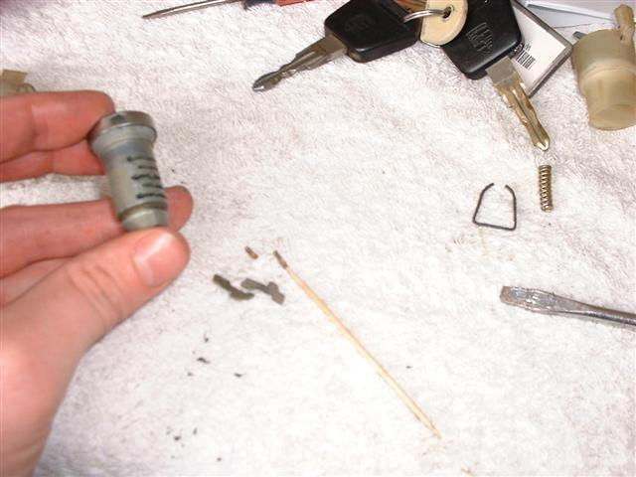

Door Locks
The non alarm Door locks have ten "tumblers" that are in opposed pairs so that the key will work both ways up. These tumblers are all numbered. If you are lucky you can rearrange the tumblers by trial and error to match the new key. More likely you will have to file down some of the tumblers to match the new key as you may not have sufficient. The door locks are easy to remove…
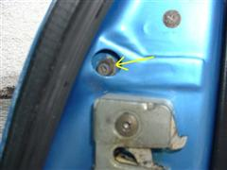
- Remove the plastic cap on the door jamb. (Yellow arrow above).
- Undo the door-lock securing bolt using an Allen key.
- Looking through the hole left by the stud pull the lock barrel about halfway out of the door skin and you should see the plastic "rod" that connects to the little ball on the back of the lock barrel. Using a fine flat bladed screwdriver slightly open the slot in the connecting rod into which the ball is inserted and gently pull the rod off the ball.
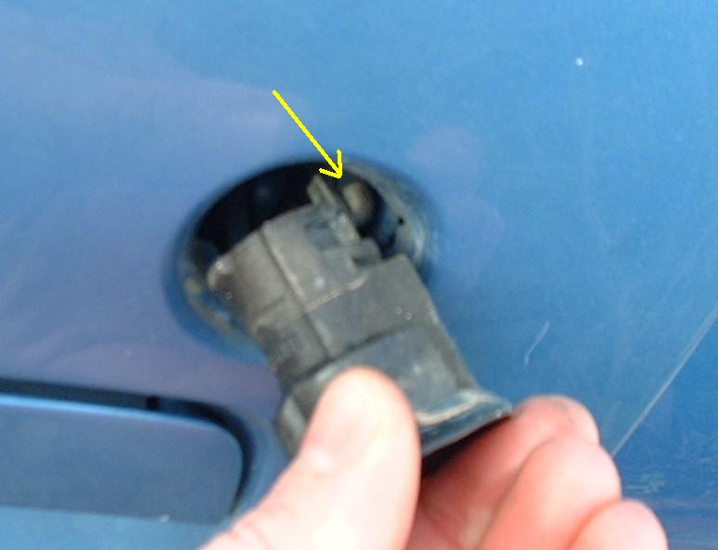
- Now pull the lock barrel out of the door far enough to disconnect the alarm wiring that is attached to the rear of the lock barrel. (Ignore this if you have no Porsche alarm system.) Tape the wires to the door skin to prevent them falling back into the door and getting lost.
- Working on a clean work surface and preferably somewhere where you will be able to find all the little bits that you will probably drop.
- If you have a key for the lock that you want to match to your other locks put the key in the lock and turn the key to the lock or unlock position.
- Using a parallel pin punch, punch the two pins (about 1mm diameter) and about 4mm long into the centre of the lock. They can only be punched in when the key is inserted and turned. (These pins retain the cylinder of the lock inside the outer barrel.) The pins will then be loose inside the lock barrel and may just fall out - I can't remember so take care.
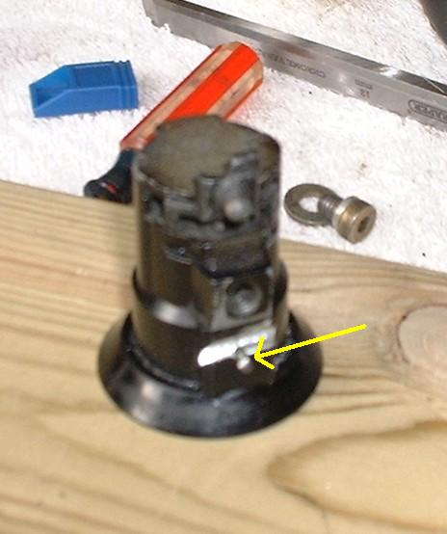
Note: If you are trying to fit a new/secondhand lock to which you don't have the key. Re-keying still possible - the only difference is that you have to remove the cylinder retaining pins outwards. Do this by sawing with a fine hacksaw blade at a shallow angle through the wall of the cylinder hitting the pin about 1.5mm down from the outside of the barrel. The pin can then be prised outwards using a sharp wood chisel.
- Using the key pull the cylinder out of the barrel.
- If memory serves me correctly you may have to use a short key to do this because the alarm bit of the lock actuated by the long key is a separate cylinder at the rear and does not come out of the front. It should be obvious when it is all in front of you.
- You should then have the cylinder with the key still in it with the ends of brass tumblers (little brass plates) just visible in the sides of the cylinder.
- When you pull the key out all the tumblers will fly out and you will loose them all! In reality they are probably all stuck in with congealed lubricant. Gently pull the key out - the tumblers will probably slowly ease themselves out of the cylinder until the springs have reached their free length. Prevent them falling out by putting you fingers over the ends of the tumblers.
- Put the new key (that matches the other lock/s on the car) in to the lock. You will then see which tumblers need to be changed.
- The non alarm locks have ten "tumblers" that are in opposed pairs so that the key will work both ways up. There are, I think, 10 possible tumblers of which your lock will use five pairs.
- The tumblers are all numbered. If you are lucky you can rearrange the tumblers by trial and error to match the new key. Keeping pairs together.
- More likely you will have some that work and some that won’t. When you have as many correct as possible, put the new key in the cylinder and file down those tumblers that remain proud of the surface of the cylinder.
- Using a toothpick, it is pretty easy to pull the springs out, to check and clean them.
- The cheating way to do it is just to put the new key in the old lock and file down all the tumblers to match. Both keys will then work in the lock plus maybe some others, but how many budding 928 thieves are walking around with lots of different 928 keys to try?
- Reassembly is essentially the reverse of the above. The little pins drive in from the outside of the lock though. Reconnecting the connecting rod to the ball on the lock barrel can be frustratingly awkward but it is possible.
Note: When rearranging the tumblers you will find some too high and some too low. The high ones will give against the spring and the low ones will feel firm. Swapping a high one with a low one is a quick way to get two the right height. You'll see what I mean.

Petrol Cap Lock
There have been numerous articles on various discussion groups both recently and in the past about self help with locks. I experimented at the weekend with my petrol filler cap lock as a precursor to having a go at some of the other ones on the car and was surprised at how easy it was to make one of my existing keys fit that lock. Here are the steps I followed:
- Separate the red cap from the white nylon screw down cap - just poke a screwdriver up between the red and white bits (3 push fit clips around the circumference).S
- Now you can remove the lock assembly from the screw cap. It has two 'ears' sticking out of the sides and a sprung-loaded button at the bottom.
- Just up from the sprung loaded button is a wire clip inserted from the side which holds the cylinder in place. Remove that with a small screwdriver or similar.
- Push the top half of the cylinder out of the bottom half - it splits on a level with the two 'ears'.
- The lock barrel itself will now push back out of the top half of the plastic housing.
- Put in the key you want to fit the lock and rearrange the tumblers to suit - you may have to file the tops or bottoms off some of them. With patience I was able to find a combination that worked with no filing necessary. Beware there is a tiny spring under the shoulder of each tumbler, but they're not very strong so they shouldn't fly out.
- Reassemble. You will have to squeeze in the sprung loaded button to get the cam on the end of the barrel to engage in a slot in it.
- There are other similar posts for door locks on other forums. I hope this encourages some to try adjusting the locks themselves before spending £25 or more per lock for a new set.

PORSCHE 928 DOOR LOCKS PROCEDURE
PORSCHE 928 DOOR LOCKS, by Wayne Strutt
The door lock was damaged by someone attempting to gain access to my car. I ordered a used lock from 928 International. It would have to be changed internally to use my key.
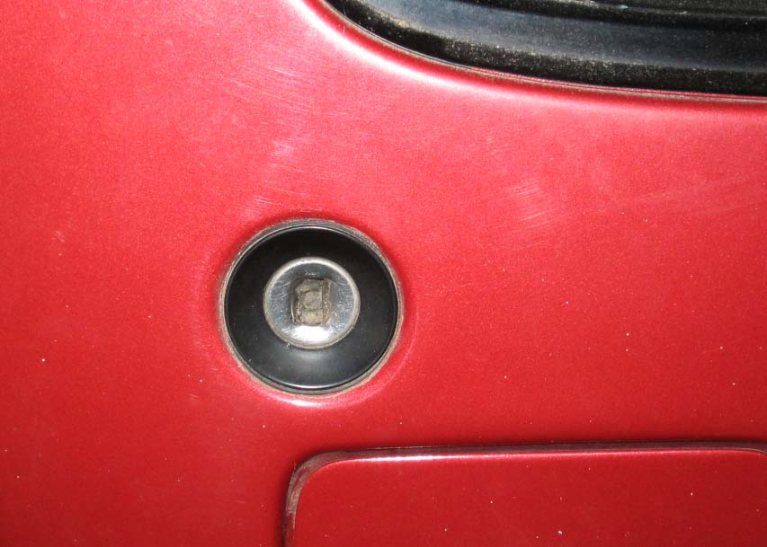
To access the door locks first open the door and remove the rubber plug just above the latch in the end panel.
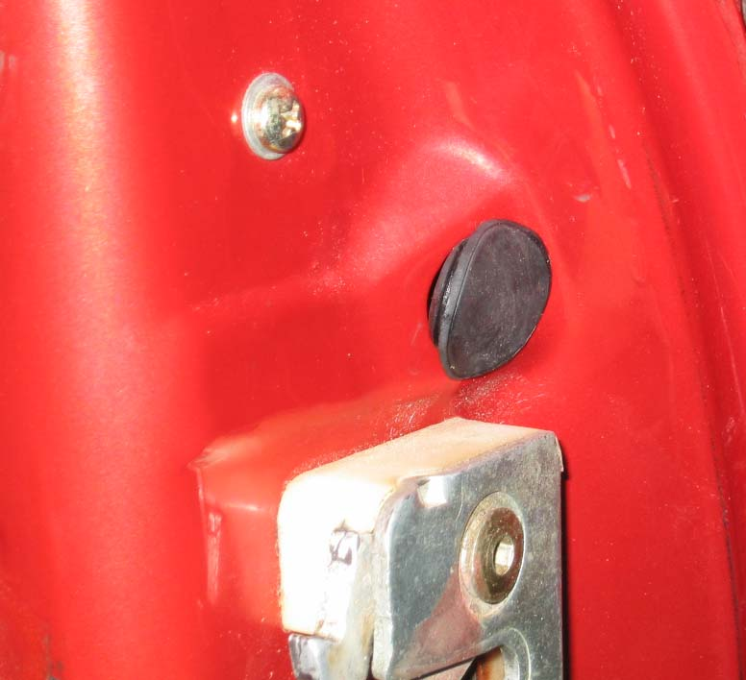
You will now see a 5mm Allen drive machine screw. Remove that screw carefully without dropping it or the 2 washers in to the door cavity or you will have to remove the inner door trim and panels to retrieve them.
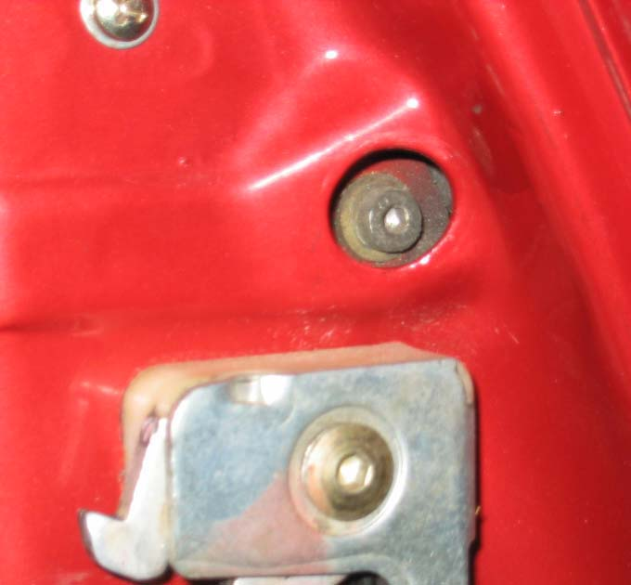
Now through that hole manipulate the lock body out through the outside of the door. Be careful not to damage the now old and brittle sealing washer around the back of the lock body. (If you plan on reusing it)
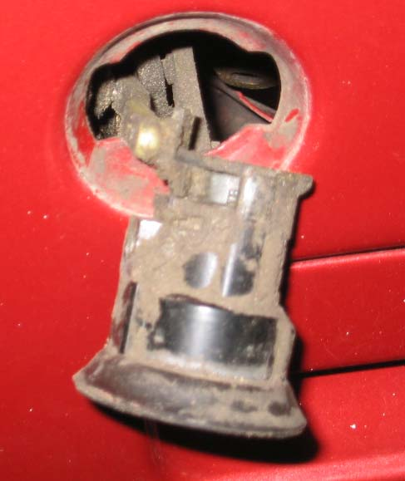
Once you can grip the lock with your fingers gently pull it out of the door far enough to facilitate removing the ball end from the socket in the lever. Tie something to the nylon lever so that it does not drop beyond reach inside the door, or you will have to remove the inside door panels to reinstall the lock. NOTE THE ACCUMULATION OF DIRT.
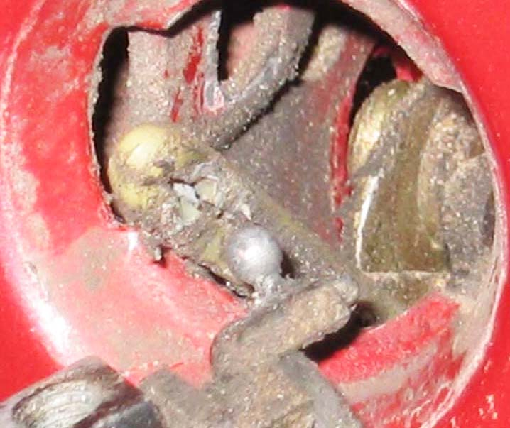
The below picture shows one of the pins that hold the core in the barrel
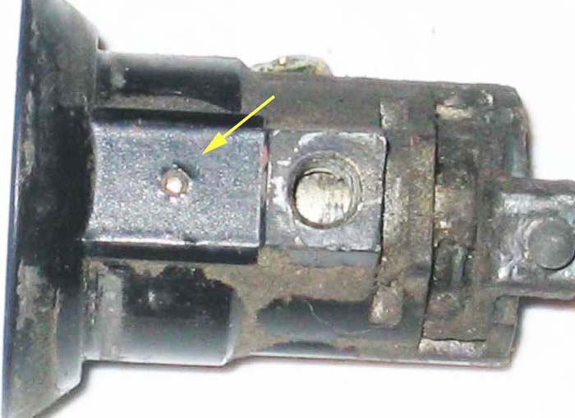
The next step is to use a spring loaded centre punch on the tiny pins in the sides of the lock body. (About a million times).
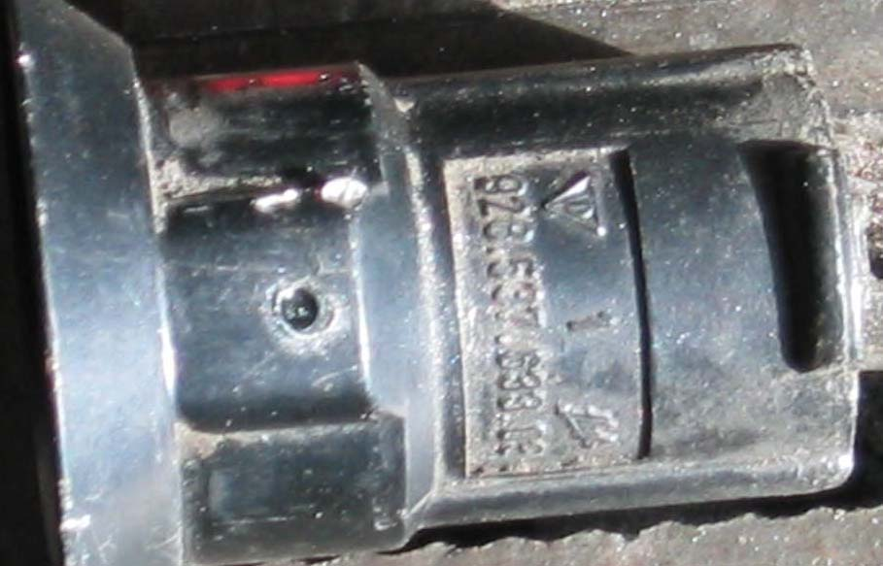
This will drive the pins down far enough to create enough of a recess to allow you to drill the pin on centre with a 1/16" drill bit. The lock body is about 3mm thick at this point but unlike the hatch lock if you hit the core you will not touch the area where the wafer pins are located, so drilling through will hurt nothing. Original pins fit through the lock housing and locate between the black arrows and rest against the shoulder of the core at the yellow arrow preventing the core from coming out of the housing
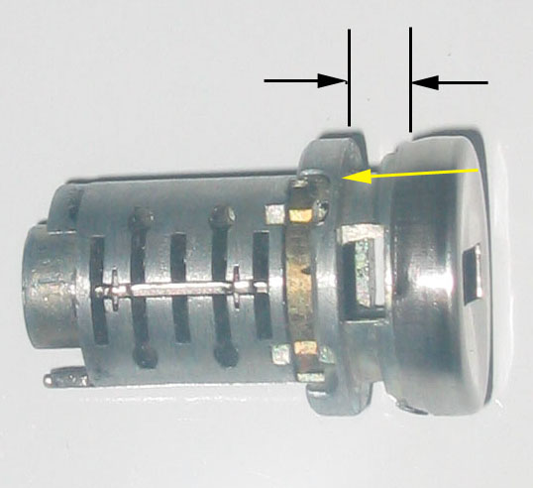
Drilling out pins
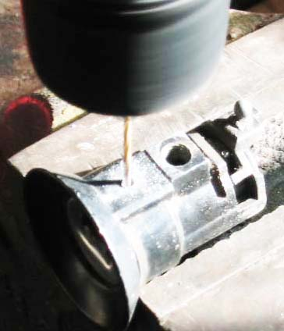
Using a diamond bit to erode the steel pin that I drilled off centre.
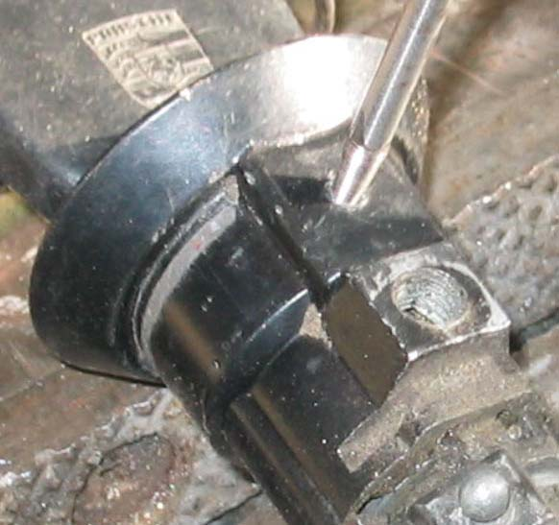
Once drilled out the core will be free to withdraw from the lock body. Keep the key in if you can as you do this. The spring on the end will be released. Don't panic this is easier to reinstall than the spring in the hatch lock. Again we have an actuator this time with a ball end that removes out the side of the lock body.
The pins that were drilled need to be replaced somehow. The internal depth of the pins is critical. The new pins when installed must be long enough to locate in the recess of the core to keep the core from coming out of the lock body but not so long as to jam the core and prevent it from rotating. Alternately you could tap the drilled holes and fabricate proper length screws that do this job. However they need to be nearly flush with the outer surface of the lock body so that they will fit through the cutout in the door. You could open the cut out in the door a bit if necessary. I drilled the body of the lock with a 1/8" bit and tapped the holes 6-32 and then using a 3/8 bit cut a bit of a recess for the screws.
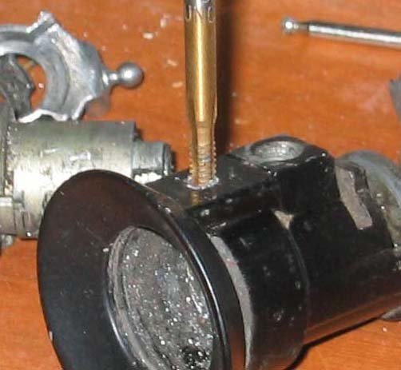
Drilling counter sink recess for screws
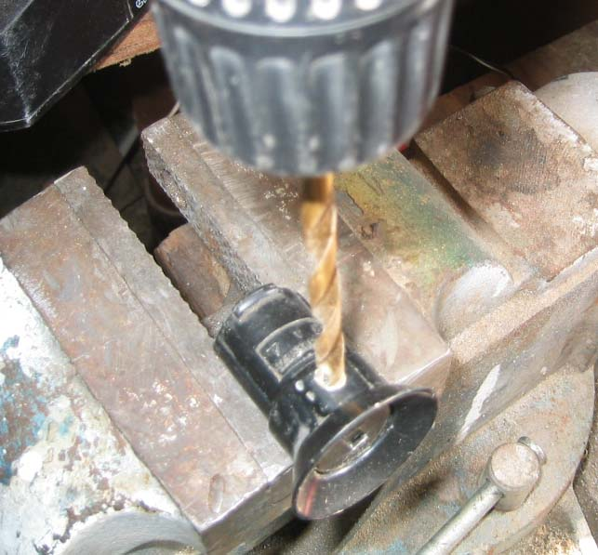
I used screws for home wall switch plates and shortened them for rotation clearance. Diameter of the screw where the thread is not needed is reduced with a file before shortening
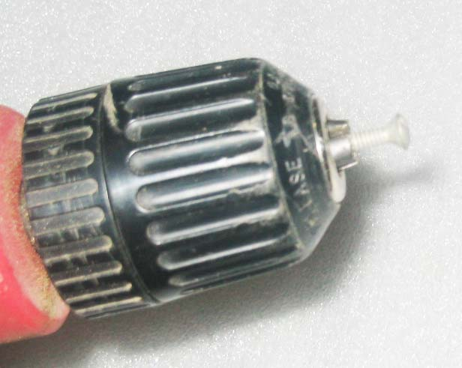
You might get by using just one screw on the same side as the tapped hole that bolts the lock to the door. The barrel of the lock is thicker on the tapped hole side, so the pin or screw on that side will be longer.
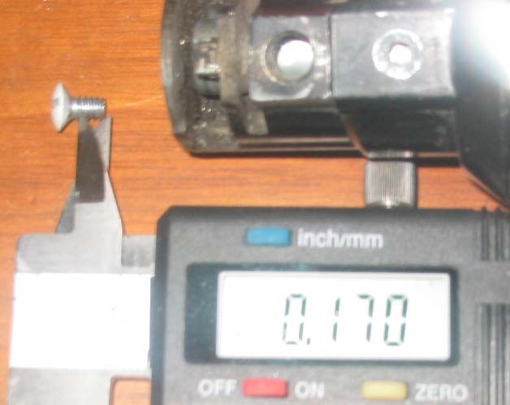
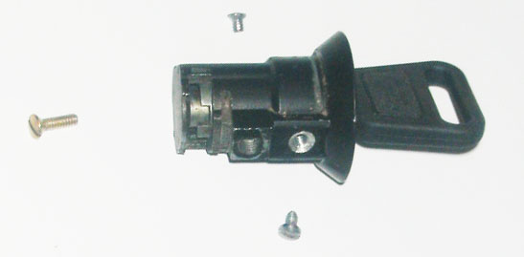
Once you have this under control turn your attention to the lock core. The core is very much like the hatch core with the basic 10 pins and additional alarm pins. Follow the same procedure for rekeying as outlined previously in this write up for the hatch lock. Again record your code as before.
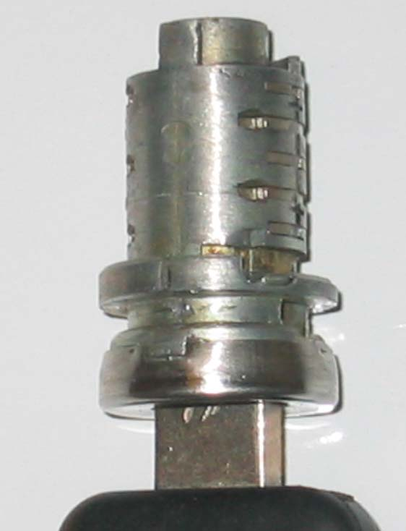
If you are rekeying to other locks that you have done use the same pins as you have already recorded in your chart. Check that you have smooth rotation. If you have an alarm lock there will be wires to unplug and the usual contact carrier as shown in the photo. Again be mindful of the fragile copper finger. Spray the pins and core with ptfe .
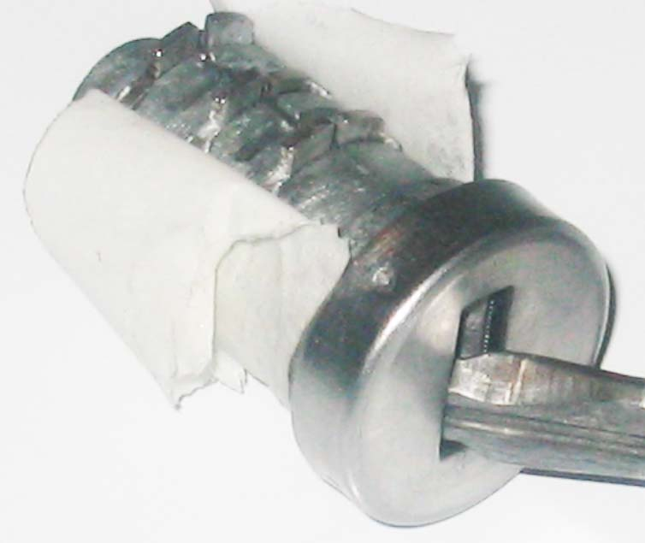
Once the core is rekeyed and the screws fit as needed you can begin reassembly. Apply a slight amount of lithium grease on the surface of the core. Not too much or it will just attract dirt.
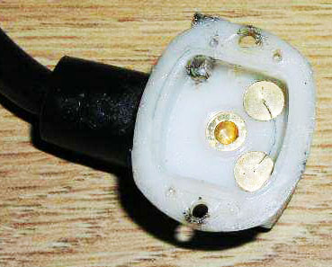
With the key removed the flat pins are pushed up by the springs to lock on to each side of the barrel ridges preventing the core from rotating. Shown in the picture below is the alarm contact of a door lock.
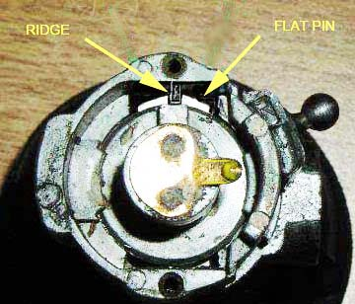
Once the core is rekeyed and the screws fit as needed you can begin reassembly.
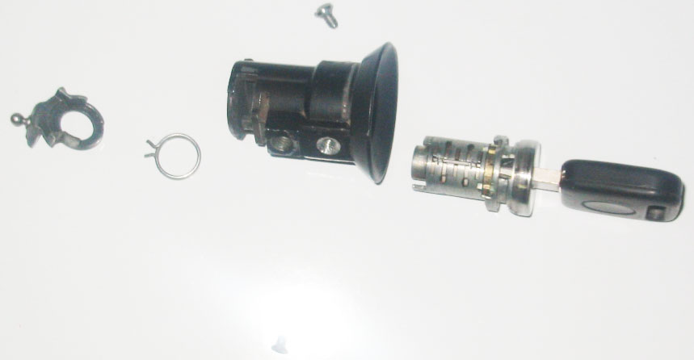
Put the spring on the end of the core with one tang against the side of the small lug as shown in the picture at the yellow arrow.
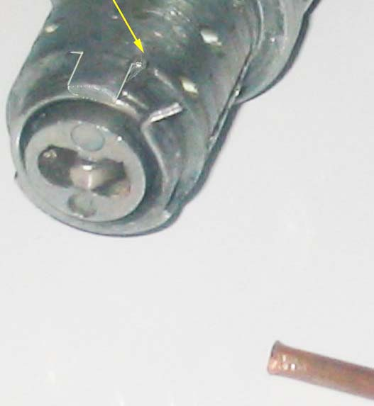
Then using something suitable (I used a piece if 1/16th copper tubing) move the other tang over to the other side of the same lug.
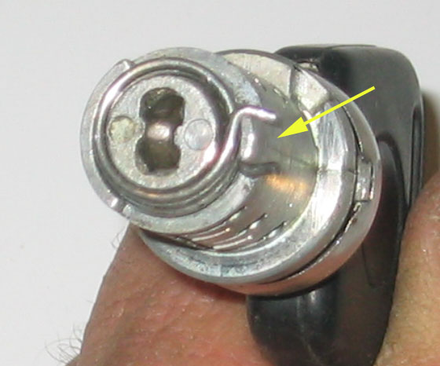
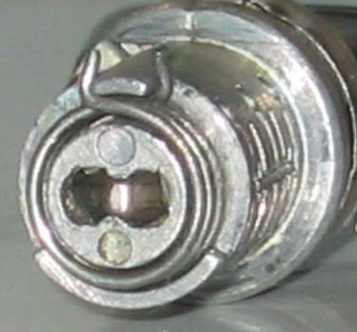
Install the actuator with the ball end into the side of the lock body. Now align the two small lugs one on the core and one on the barrel and push the core into the barrel. The spring will automatically be in the correct position.
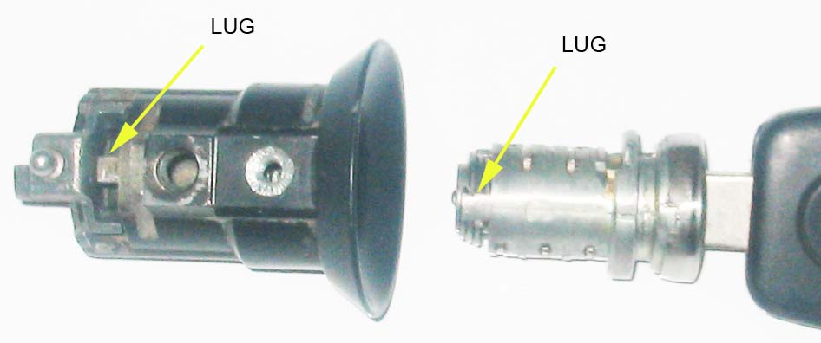
ALIGN LUGS WHEN INSTALLING CORE.
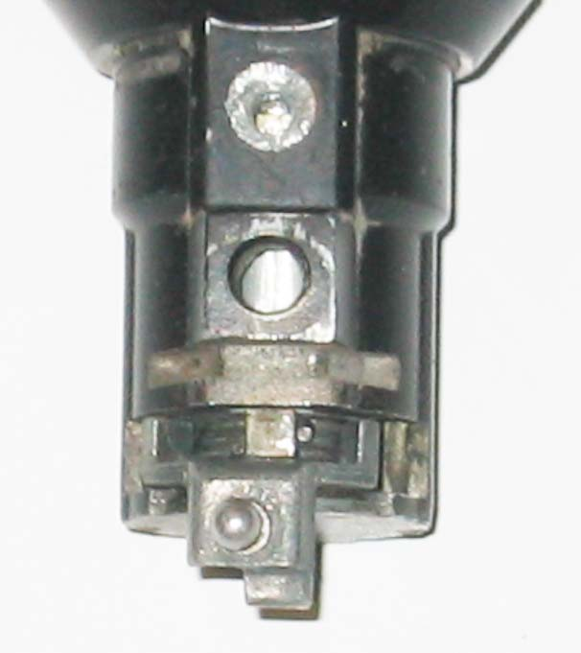
Spring installed, actuator installed, waiting for custom screws. With the screws tight turn the key left and right. It should turn smoothly and the spring should return the key to the vertical position.
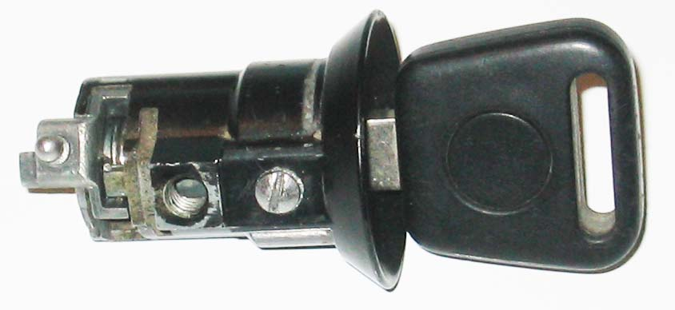
COMPLETED DOOR LOCK
If you are satisfied with the action, then unscrew the screws just enough to put some red loctite in and then tighten them. Put the gasket on the back of the lock barrel and push the ball into the socket of the lever. Install the lock into the door. Replace the 5mm socket head cap screw. Replace the access plug and you are finished.
"You don't own a Porsche 928, it owns you .Youre just maintaining it for the next guy."
WAYNE STRUTT

